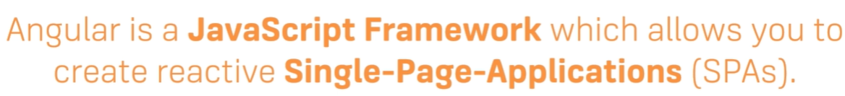

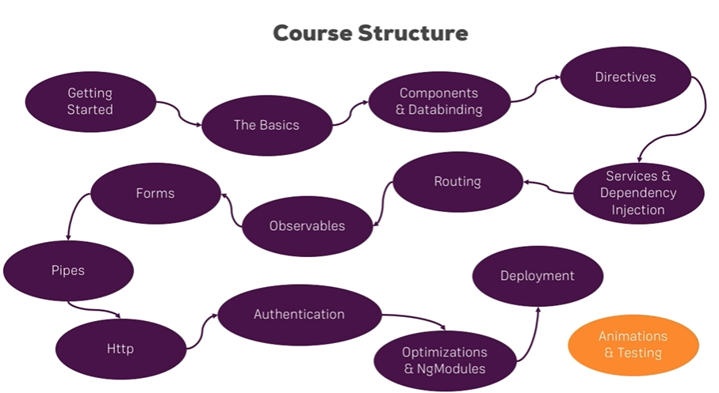

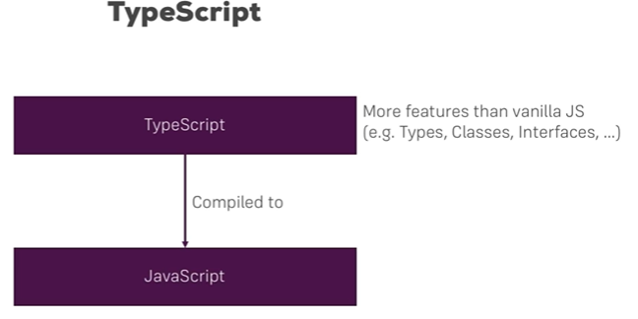

Installation :

npm uninstall -g angular-cli

npm uninstall -g @angular/cli

npm cache clean

npm install -g @angular/cli@latest

alias ng="F:/angular/node_modules/@angular/cli/bin/ng.js"

ng new project1

cd project1

ng serve

Angular run on VS Terminal :

set-ExecutionPolicy RemoteSigned -Scope CurrentUser

Get-ExecutionPolicy

Get-ExecutionPolicy -list

ng version

ng serve

Install bootstrap and jquery in angular

* Go to respective folder
* npm install bootstrap
* npm install jquery

If you want run bootstrap before do this :

* In angular.json - architect–build—style

"./node_modules/bootstrap/dist/css/bootstrap.min.css"

* In script

"scripts": ["./node_modules/bootstrap/dist/js/bootstrap.js","./node_modules/jquery/dist/jquery.js"]

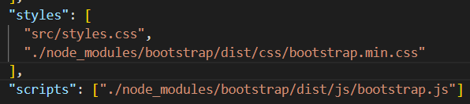

**Create components :**

ng generate component Components/todos OR ng g c Components/todos

For using ts array :

"strictPropertyInitialization": false,

Write down this line in tsconfig.json.

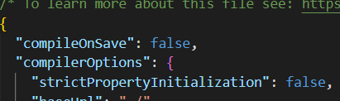

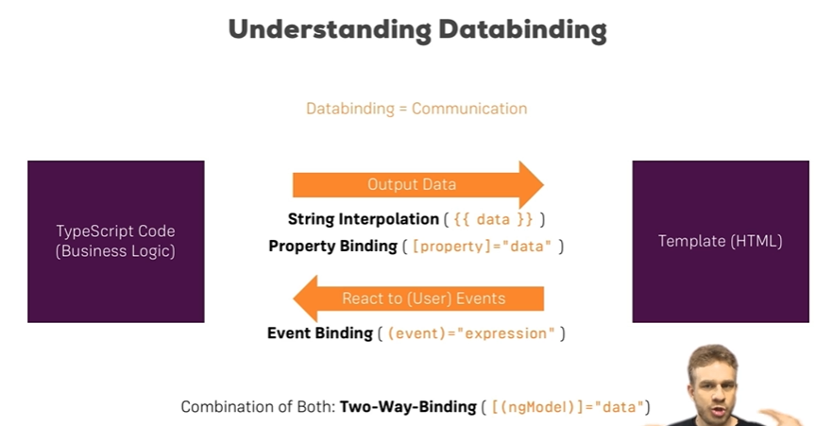

**String interpolation : Data pass from TS file to Template**

**TS file**

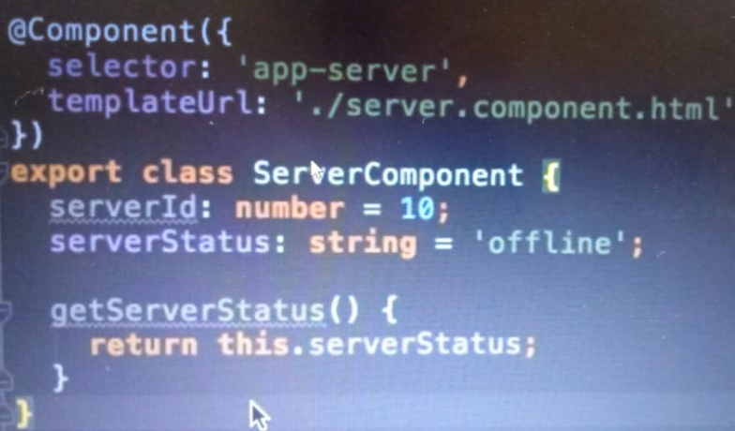

Template html file



**Property Binding: Data pass from TS file to Template**

**Template html file:**

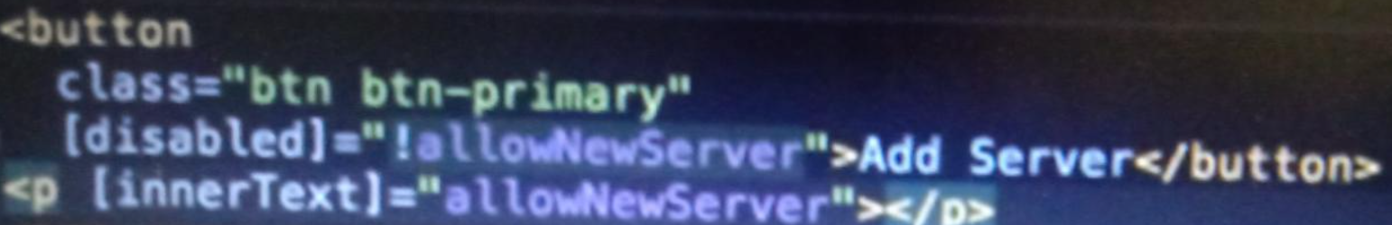

**TS file**

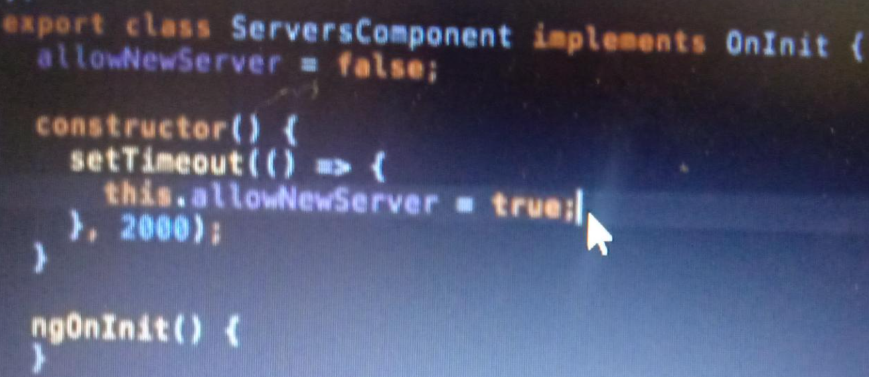

**Button click event triggers :**

**TS file :**

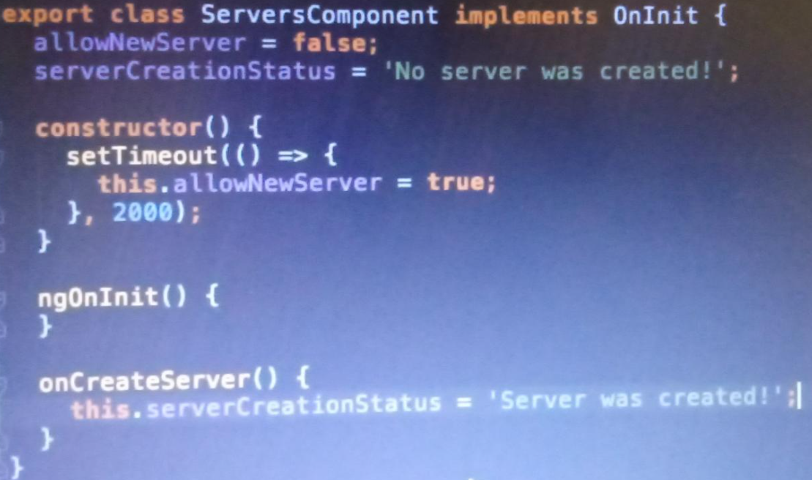

**Html file:**

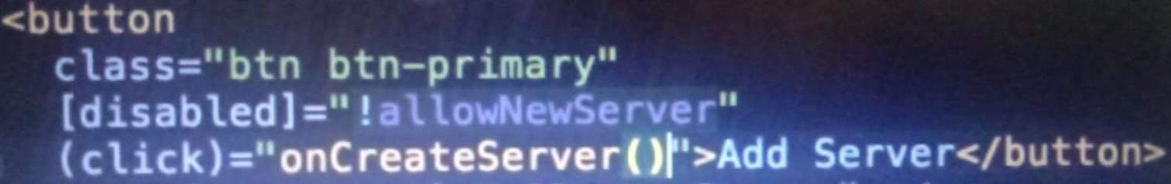

**Passing and using data with event binding**

**Ts file**

In this we have trigger event on input field with onupdateservername method so you can get direct value by event.target.value

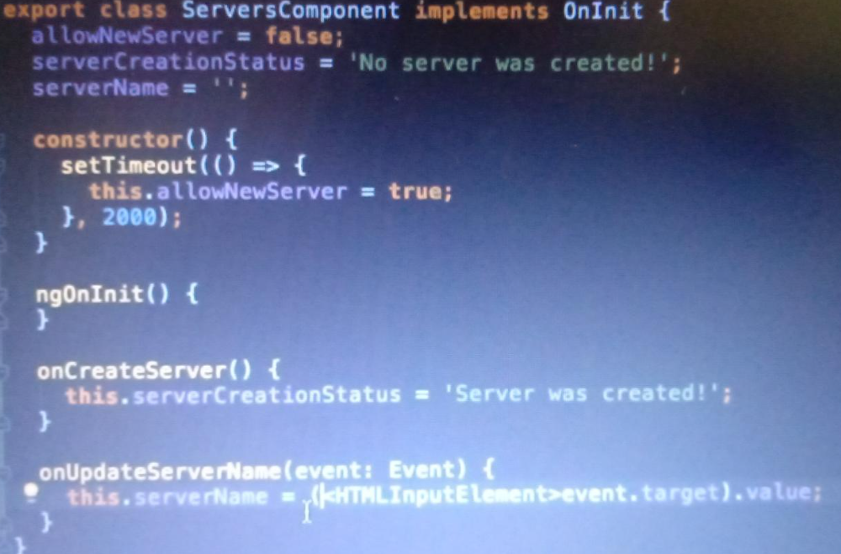

**Html file**

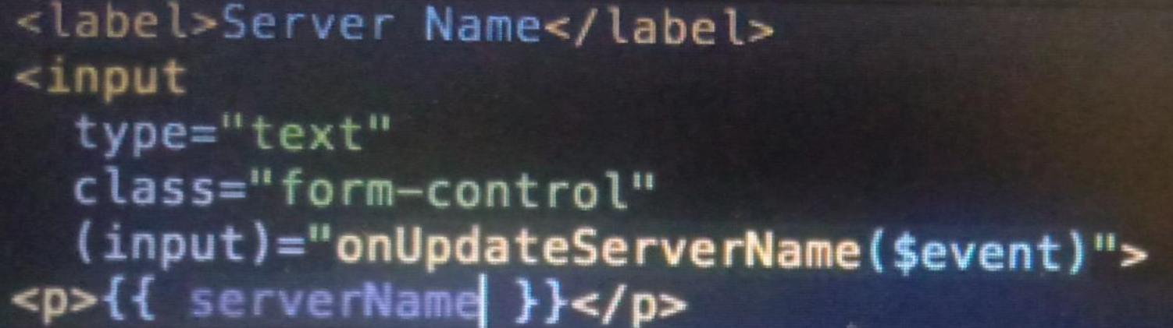

$event is reversed which used to access data. (input) it is attribute of input field.

**Two Way binding: we combined property and data binding**

**Use ngModel - configure FormModule - app.module.ts**

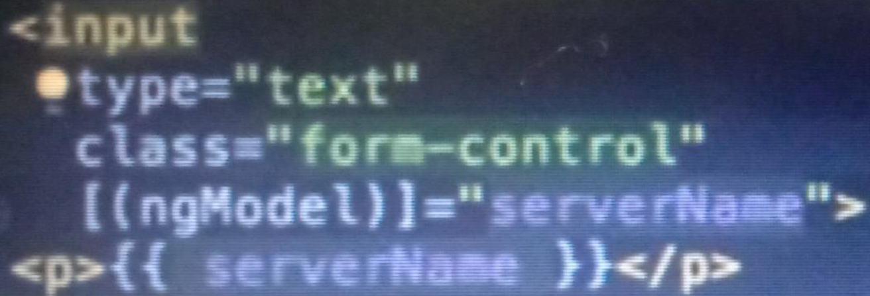

**ngif directive - it can be write in *ngif cause it’s structural directive which required start at beginning.**

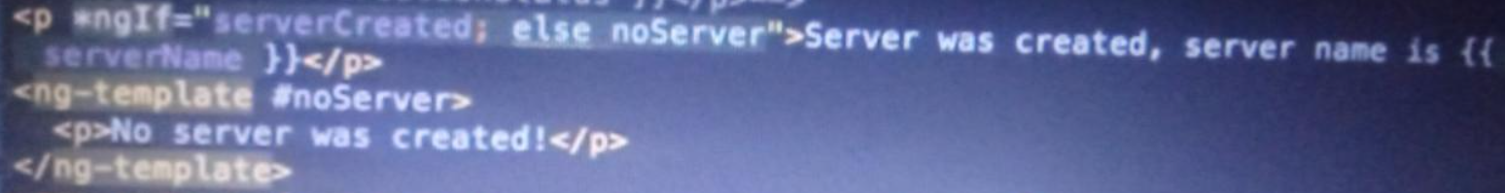

**You can use any ref for else block use any name followed by #**

**ngStyle : it’s attribute directive - it updates style with dom dynamically**

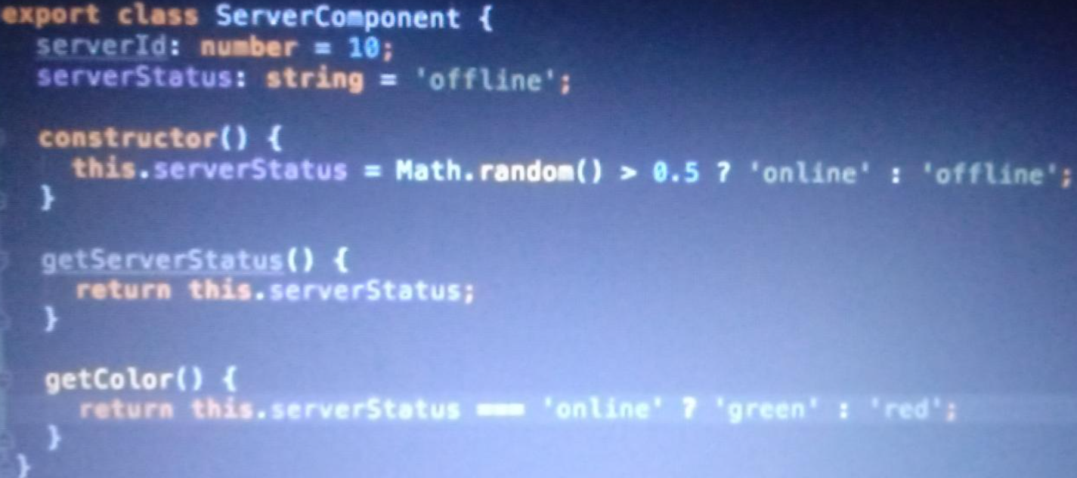



**ngClass - it adds and remove classes in inner html**

if classname is in ts file with inline styles then in html file use without quote directly like = [ngclass] = “online:serverStatus===’offline’ ”

But if your classname is in css file then in html file you have to use quote

Like = [ngclass] =” ’online’ : serverStatus===’offline’ ”

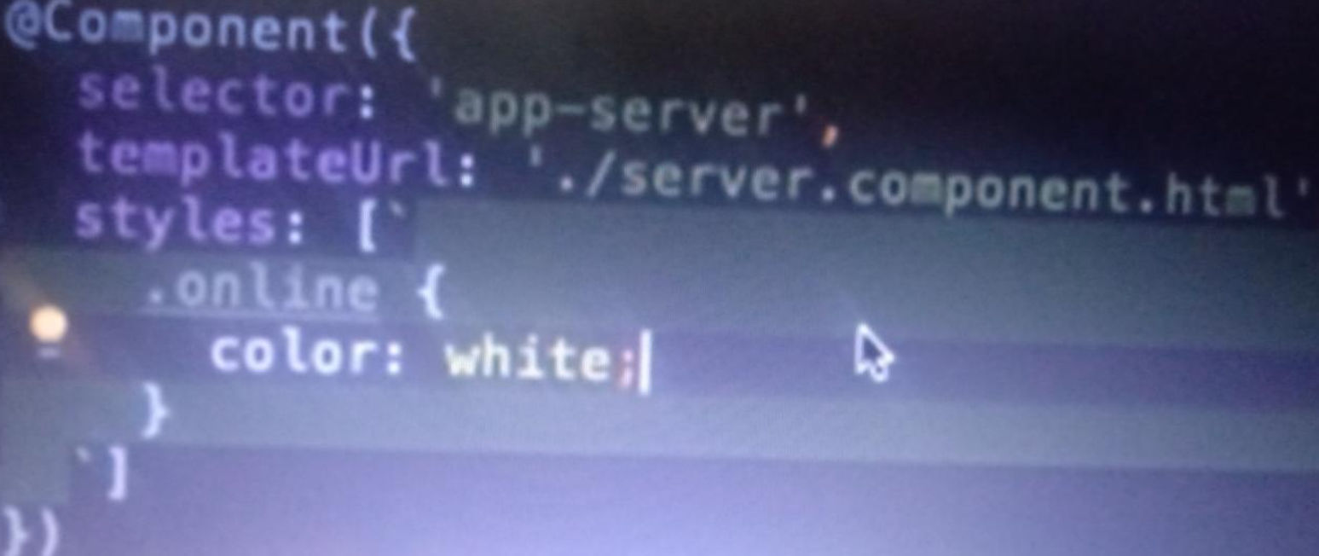

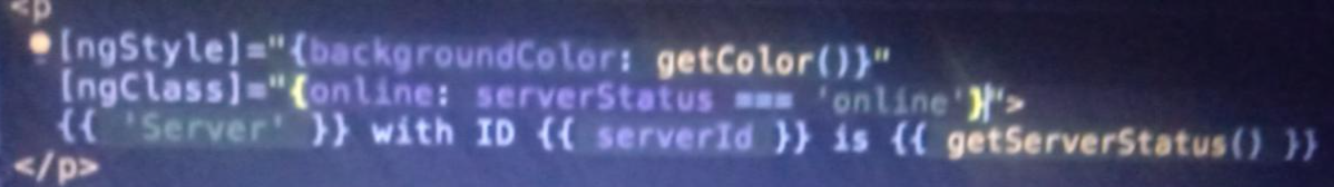

**Use For loop:**

ngFor is html directive in angular used as print element from array

<ul *ngFor="let todo of todos">

<li>{{todo.sno}} | {{todo.title}} | {{todo.desc}} | {{todo.active}}</li>

</ul>

**For loop with index :**

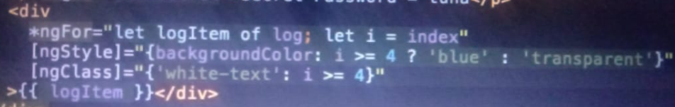

**<div *ngFor="let todo of todos; index as i">**

**<app-todo-item [todo]="todo" [index]="i"**

**(todoDelete)="deleteTodo($event)" (todoCheck)="toggletodo($event)"></app-todo-item>**

**<!--<app-todo-item [todo]="todo" (todoDelete)="deleteTodo(todo)"></app-todo-item>-->**

**</div>**

**How to create custom event and properties.**

* **Parent to child :**
* If let say child component wants property from parent then in child component you can access that property by using @Input() decorator it will make global way to take property from parent.
* 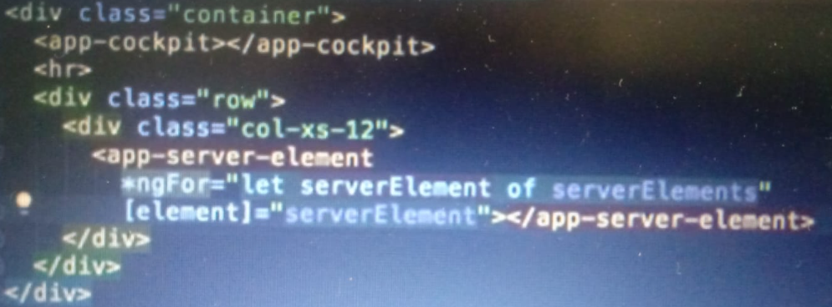
* 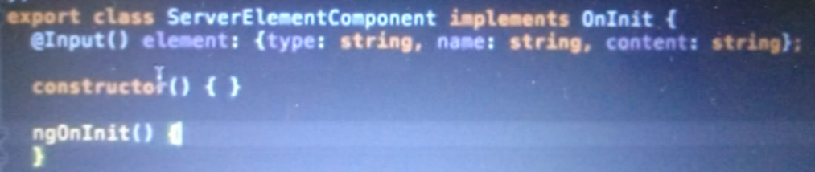
* If you want to alias your properties for bind like
* [serveEle] = “serverElement” then in child you must use @Input(‘serveEle’) element:{..};
* **Child to Parent:**
* You want event from child to parent,first in parent html create custom event
* 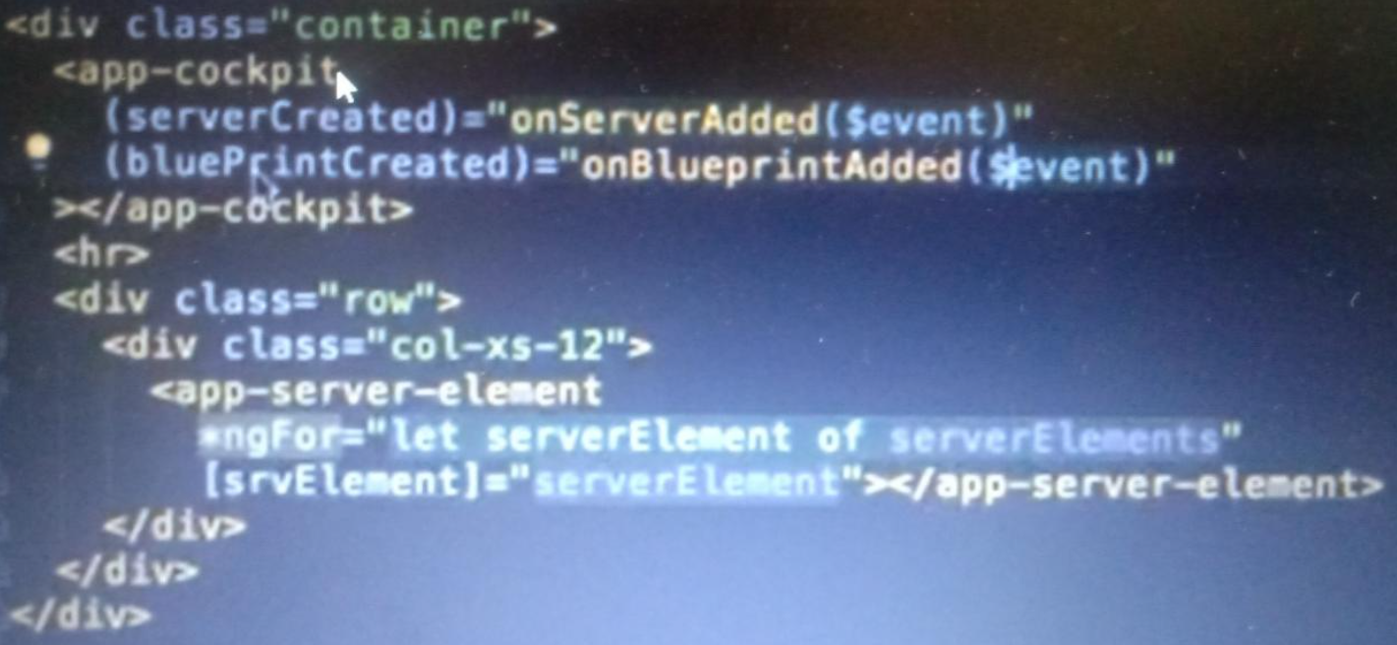
* serverCreated is custom eventname and onServerAdded is method on event occur with $event
* In parent ts write methods inside
* 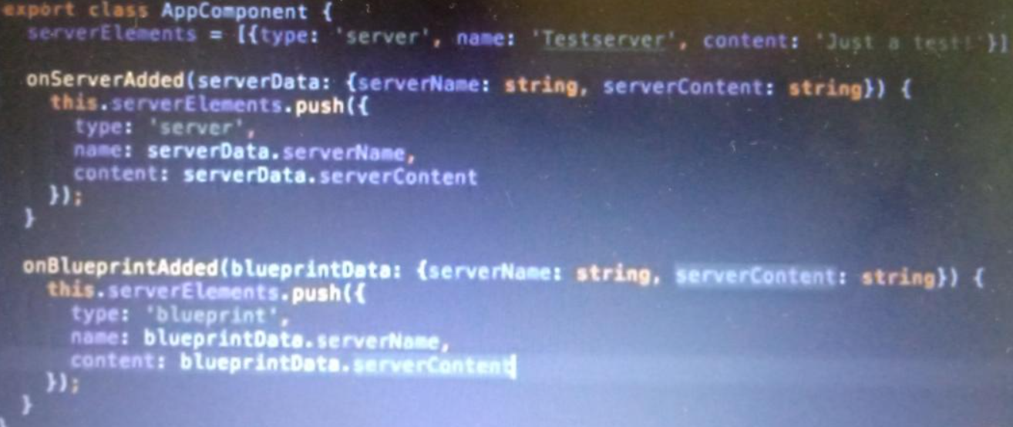
* In child ts- you want to emit your event to parent then use @output decorator and EventEmitter
* 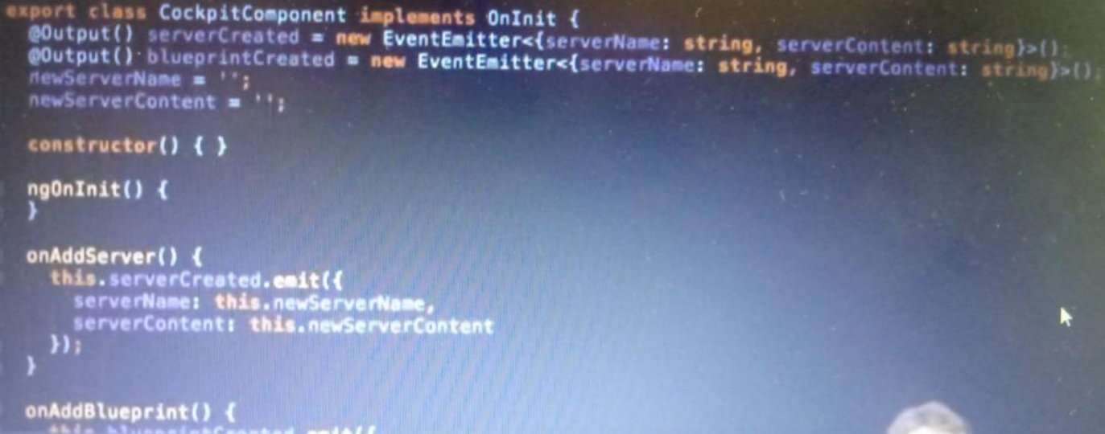
* If you want alias output you can do same as input decorator

**Alternate way to put html data to type script code**

* Use local references here in example we have put ref by # and pass through method in TS

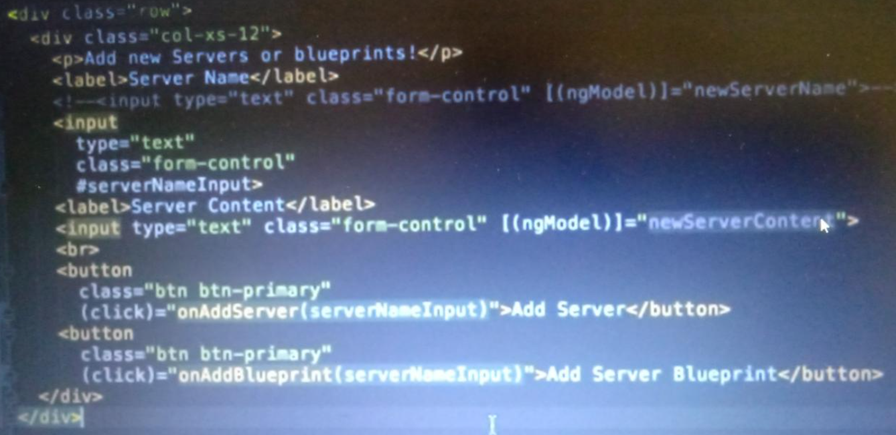

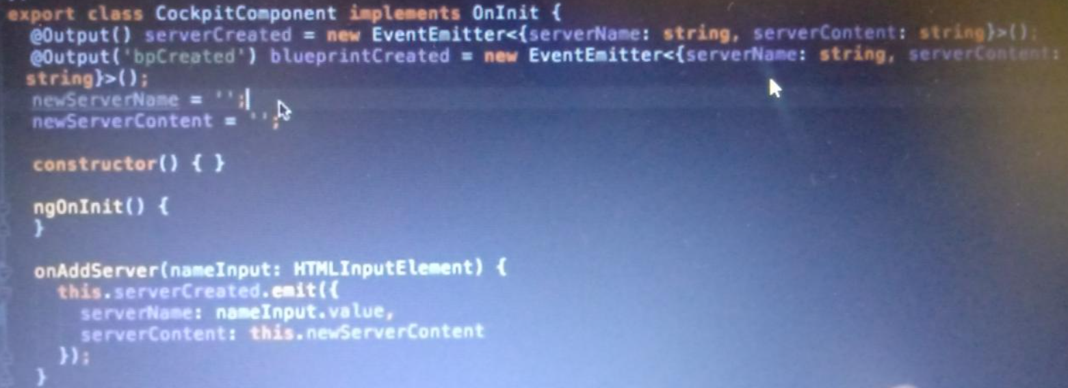

* Use view child old tech-through element ref you can get.

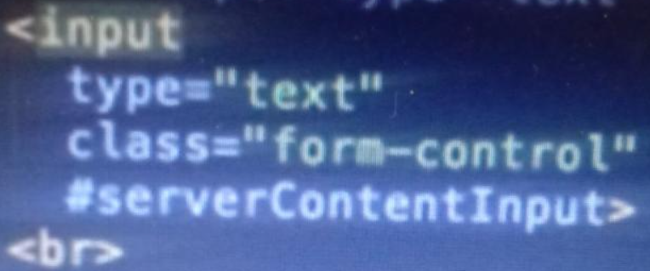

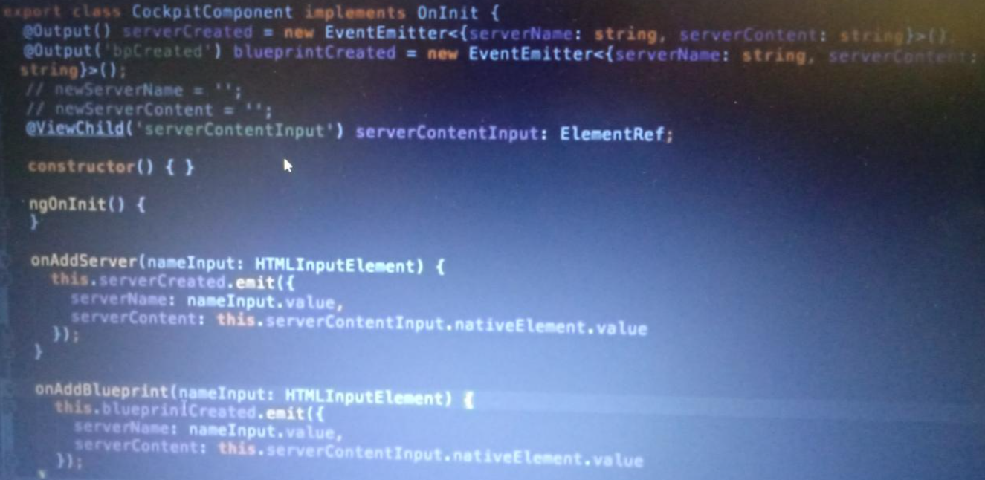

**What is ng-content ?**

* It is use ful when you want to keep all html code in selector tag
* This is child html

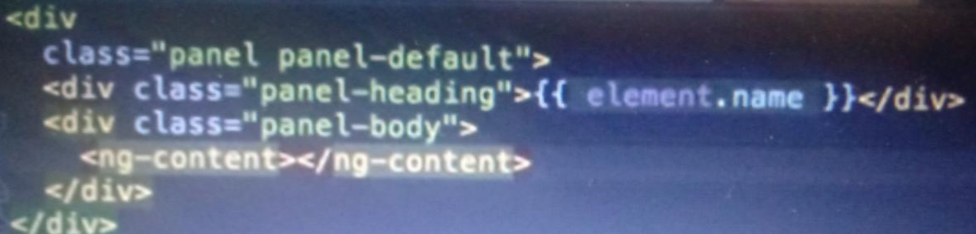

* This parent html tag

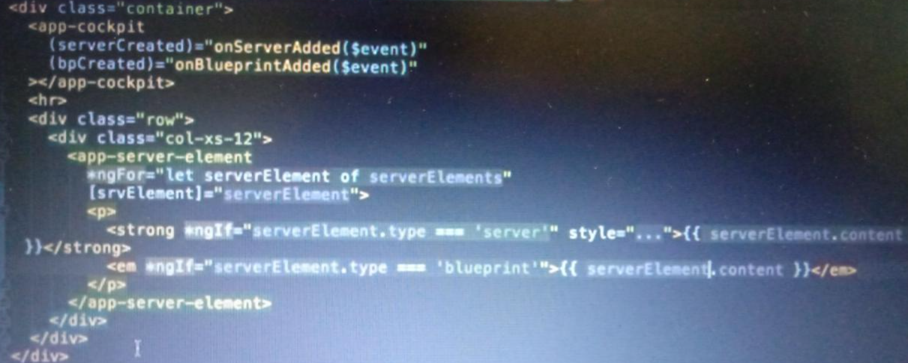

**Lifecycle:**

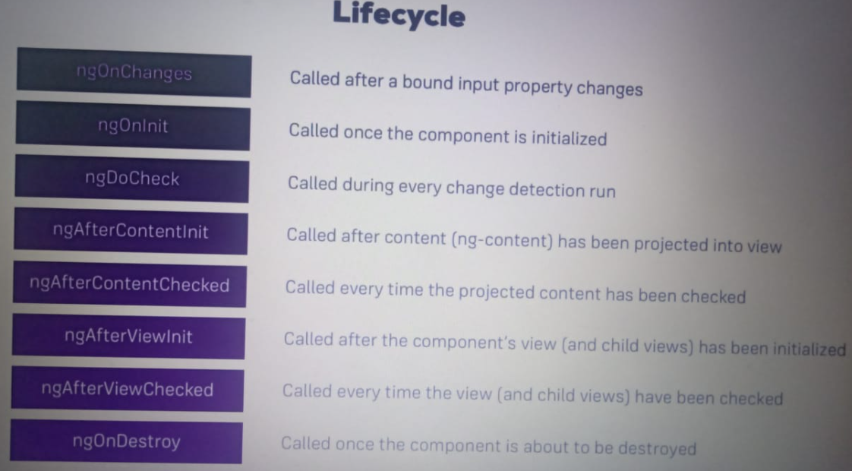

ngOnchanges = will give you previous and new value

ngDocheck = it will run if any changes come in app

ngAfterContentInit = it will run onces

**How to get content child from parent to child via ng-content**

Parent html

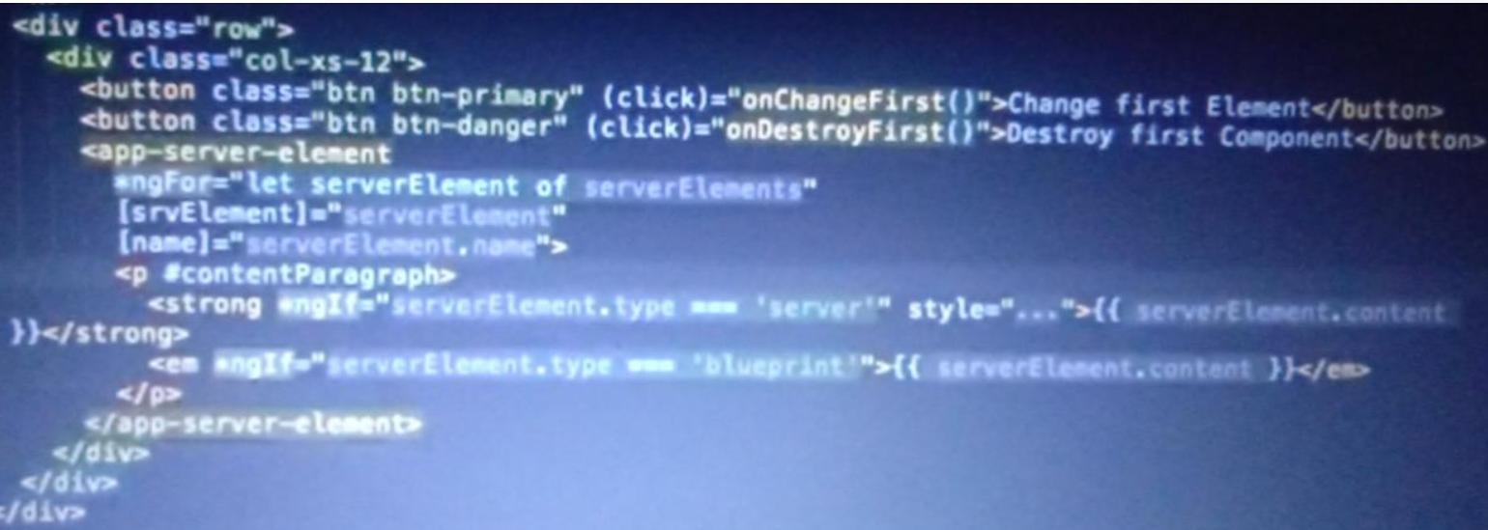

Child ts

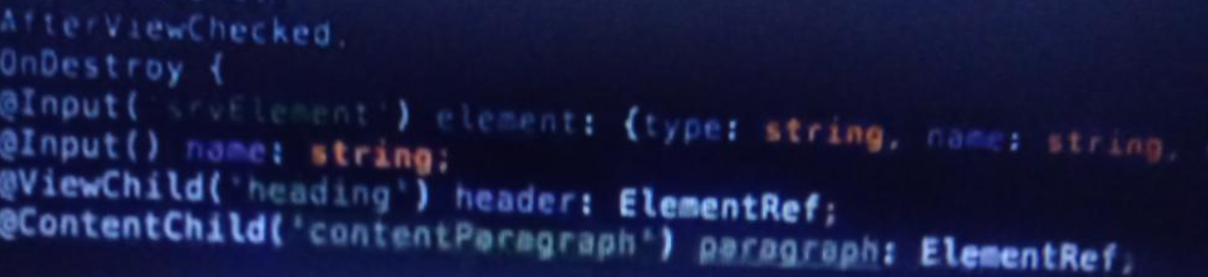

To get data it is same view child like = this.paragraph.nativeElement.value

**Create your own directive :**

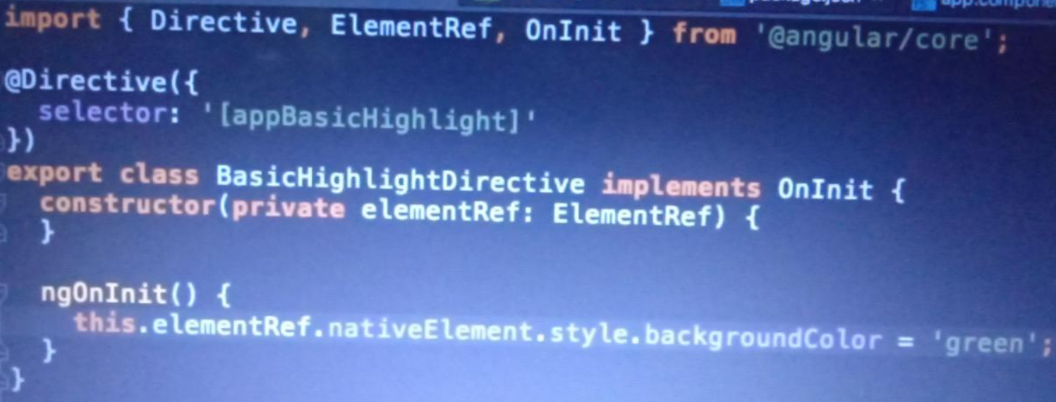



Add this directive BasicHigh…in app.module.ts file in declaration

**Alternate way to create directive : it is best way**

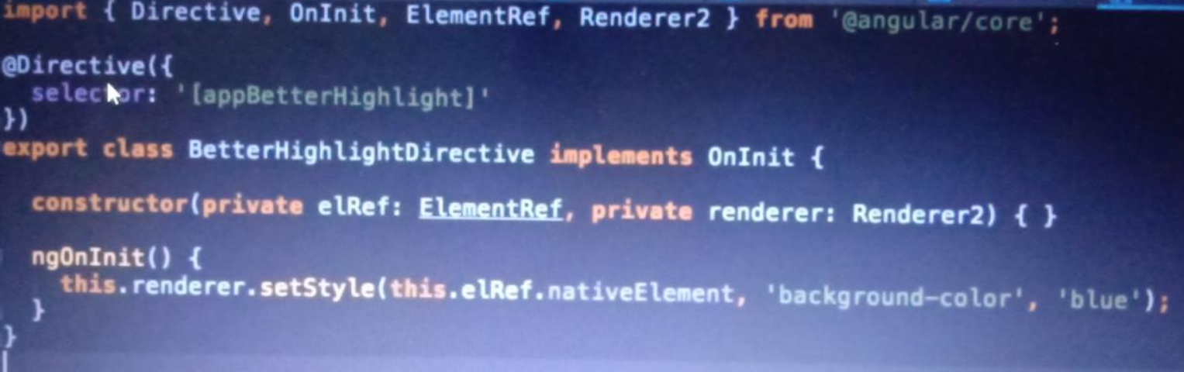

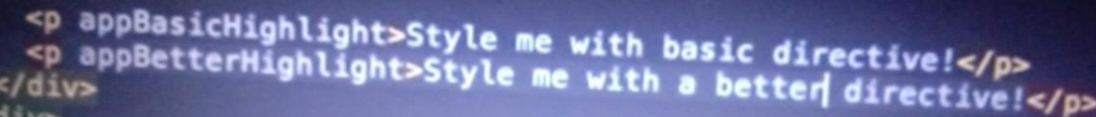

**setStyle(ref,style,value);**

**Use HostListner : it is used when you want to something on style it will listen those event**

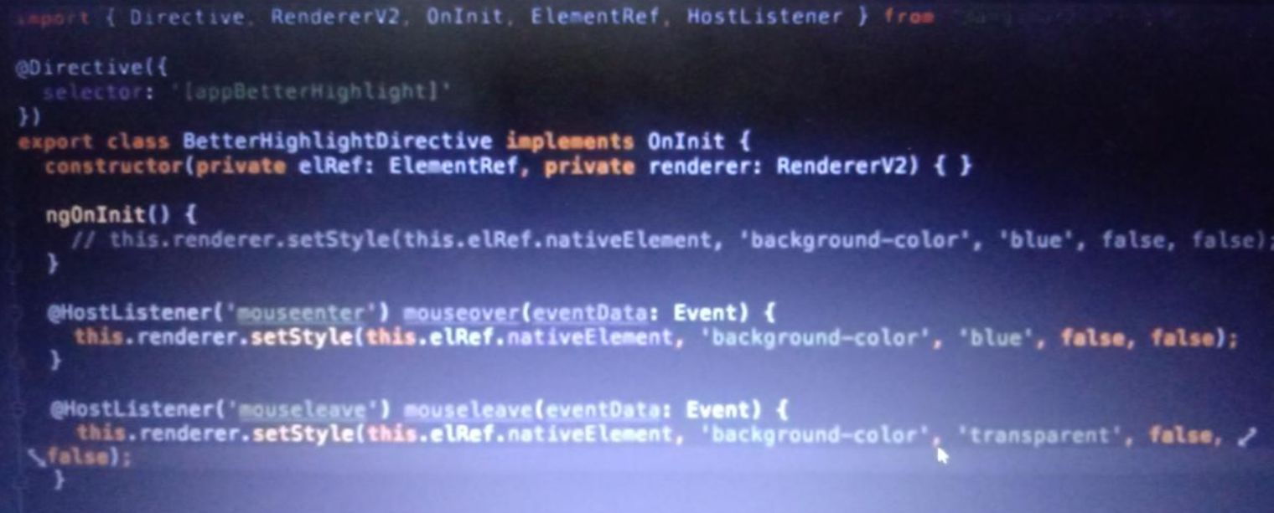

**Alternate way of rendered- use HostBinding**

It also used to bind property of style directly via directive

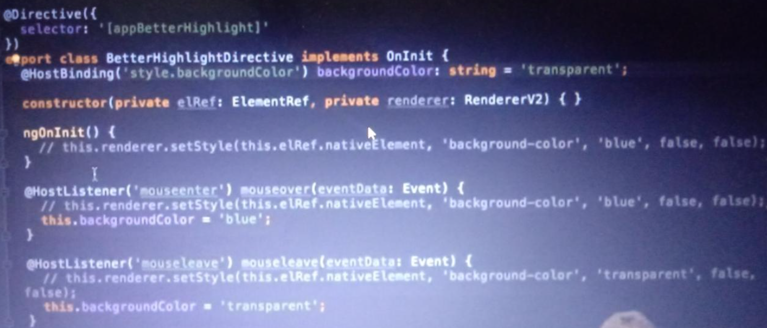

**Services :** It is used to don’t repeat your work all time let say logging data

How to create service in angular

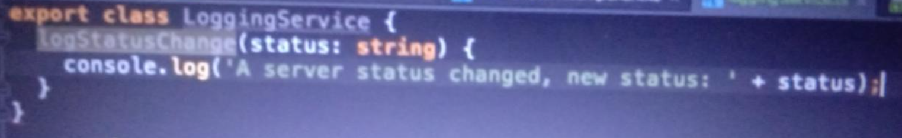

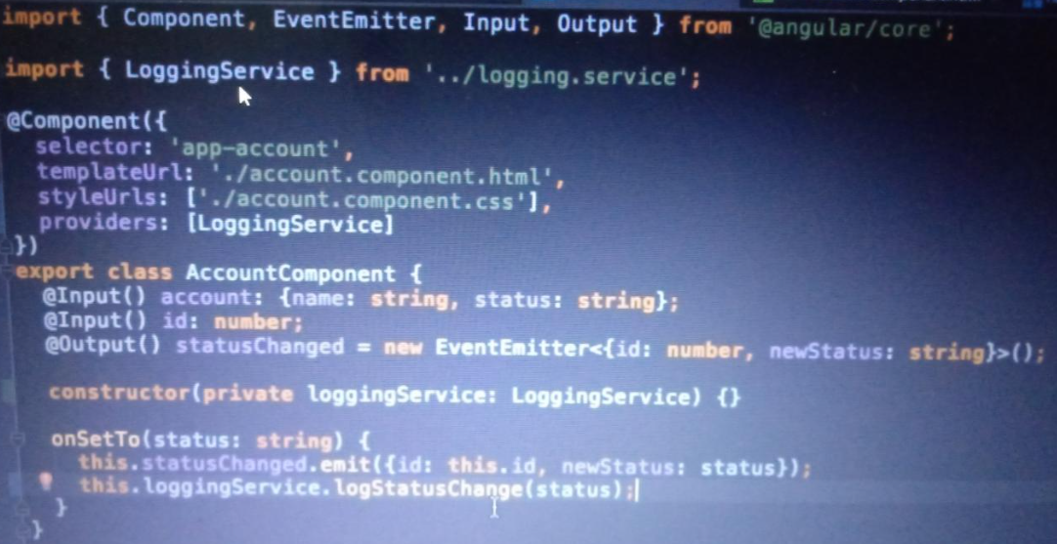

Here actually angular created service instance by constructor and providers so that you can replace your duplicate code

**How to use array or data with services created ?**

Let say if u have data of parent app and created service of it and create array of account and all method of it.like add account and update account.

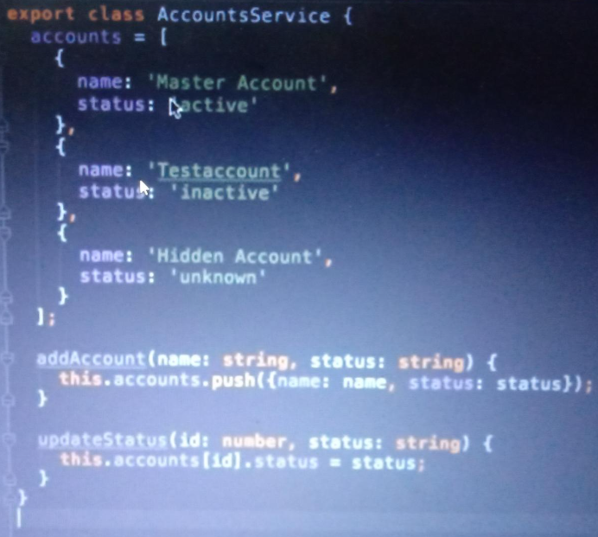

Initially this inside app component and you are taking all data from it’s child by emitter but here we don’t want we will use services

Let see how we can get this services in newaccount and account

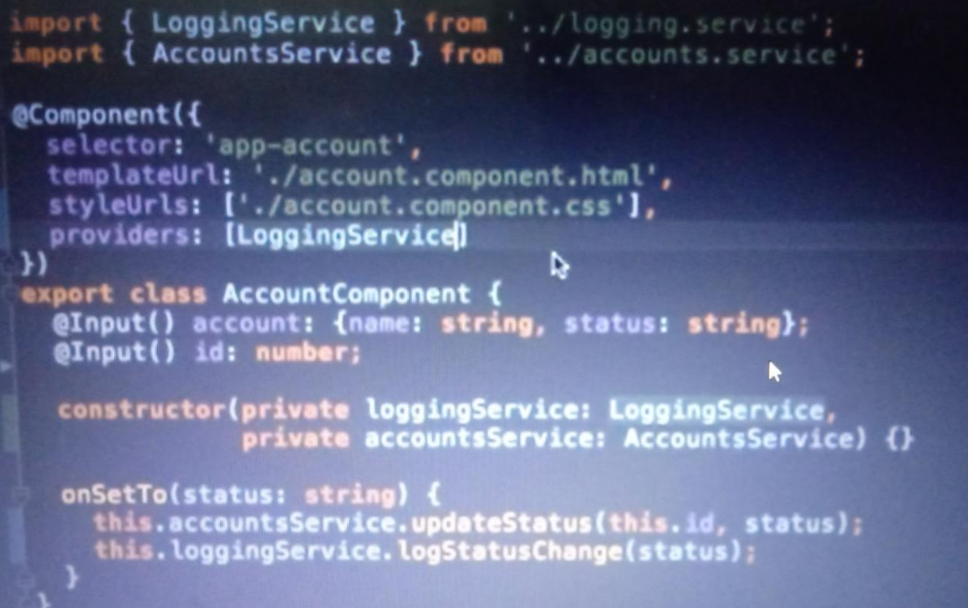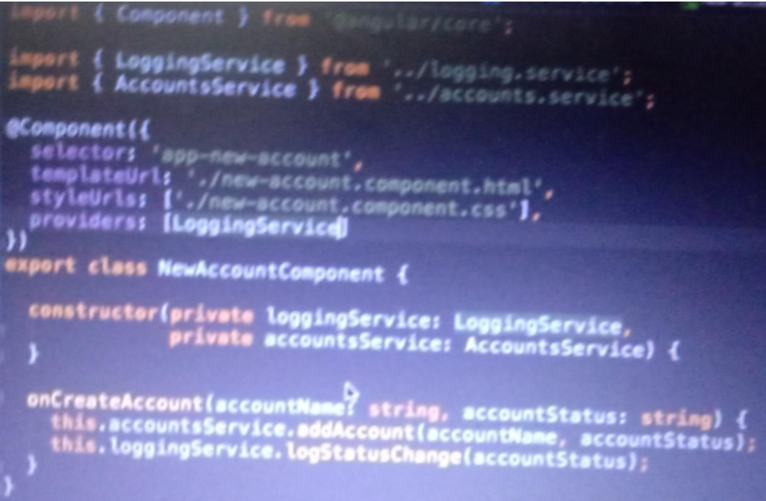

In this account component we are not using event emitter for account we will use centrialized services through constructor only but note that don’t provide providers otherwise it will create separate instance of every services in constructor.

**How to to services in services ?**

* First you have write two services name in provider in App Module
* Then after in account Services you have to inject other service like logservice
* You have write @injectable and you will use log services by constructor itself.
* 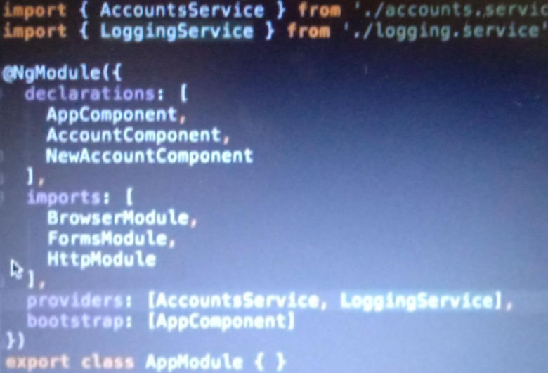
* 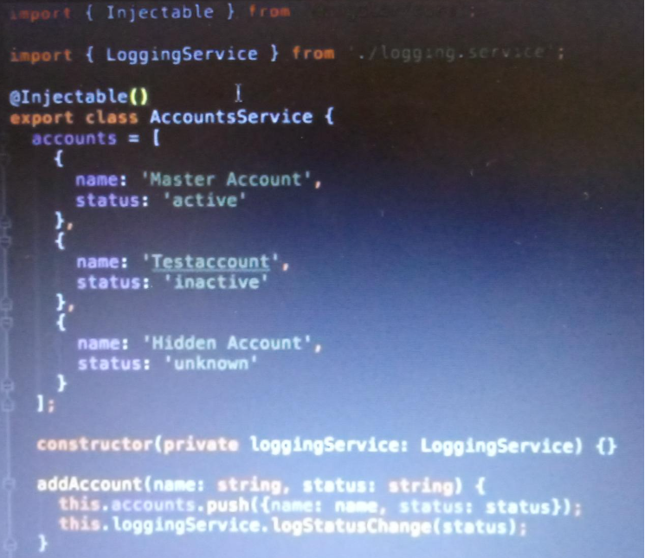

**How to do cross communication via services :**

* You have account services inside log services and account TS right
* You can emit thoes events in log services and account services in ts file.
* You can subscribe thoses events in newaccount ts
* Create new serviceUpdate var as emitter

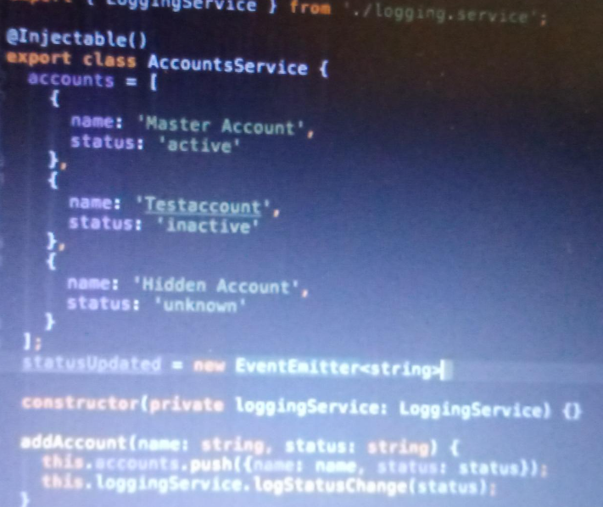

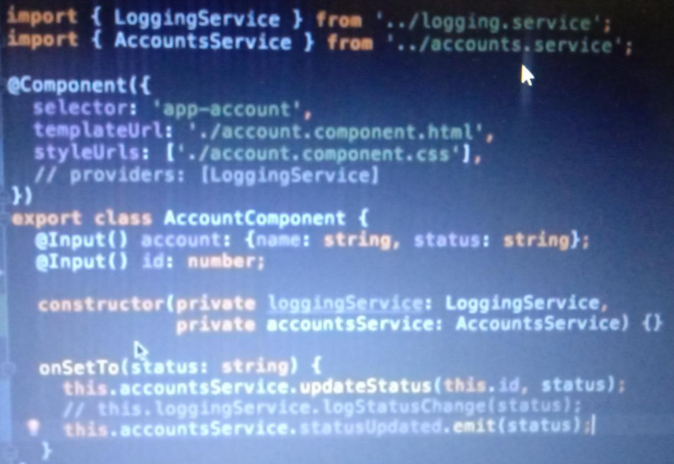

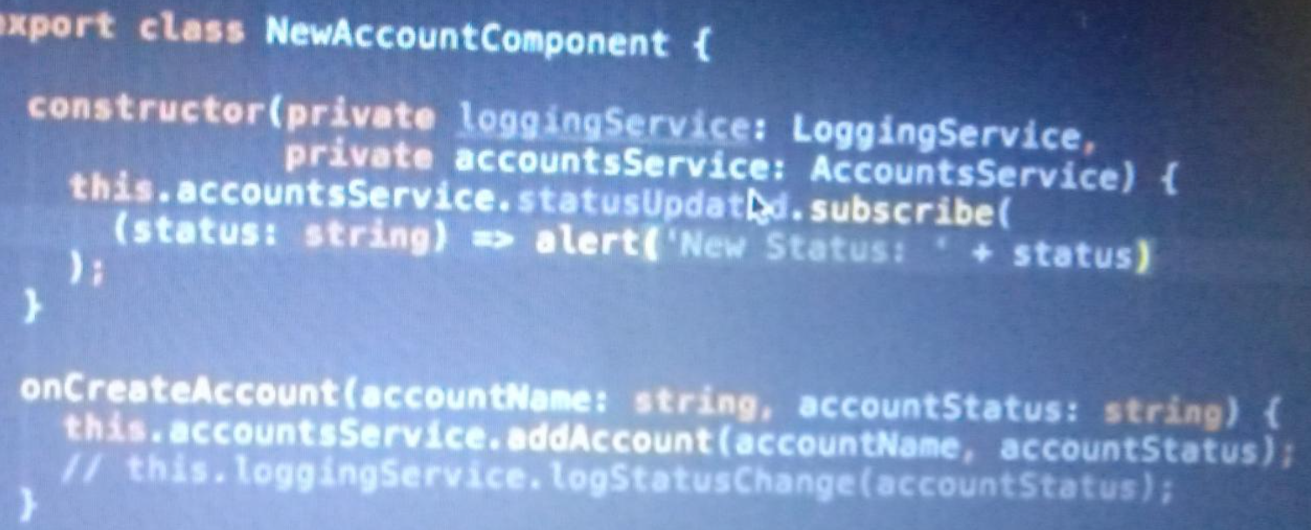

**Routing :**

**In app module ts**

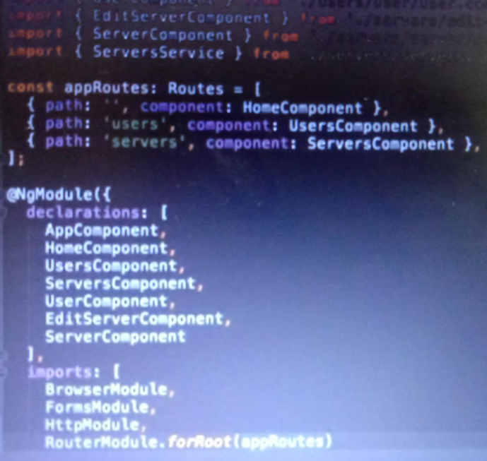

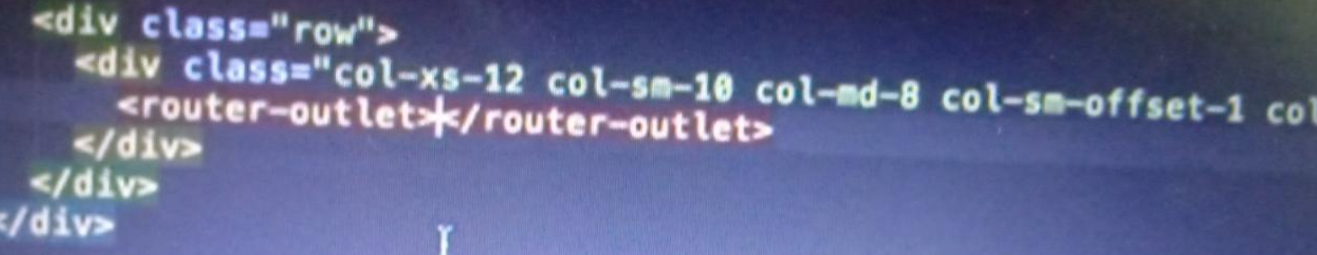

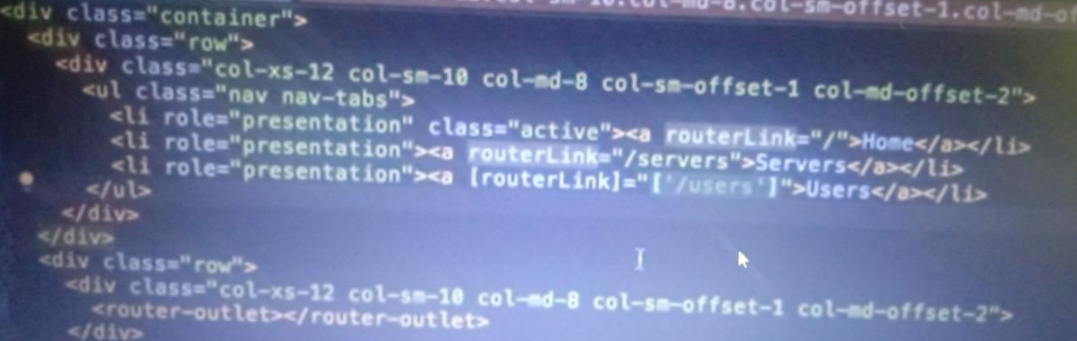

**Make Active Links :**

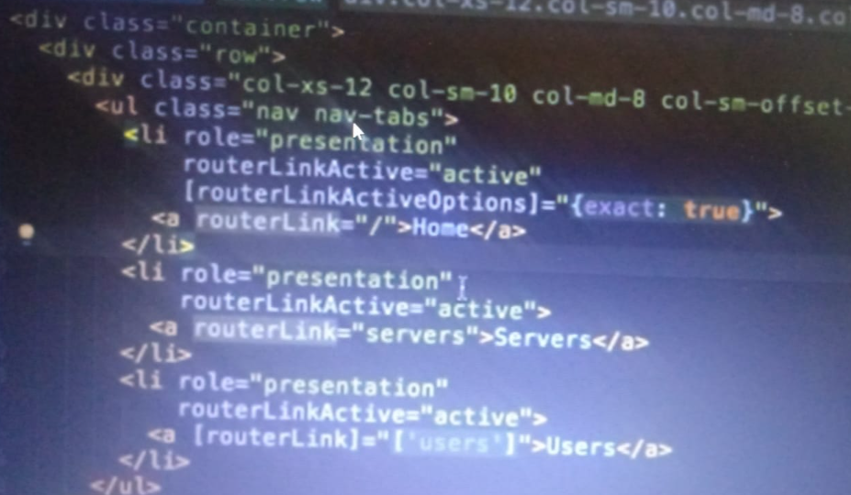

**How to navigate to link on clicking button**



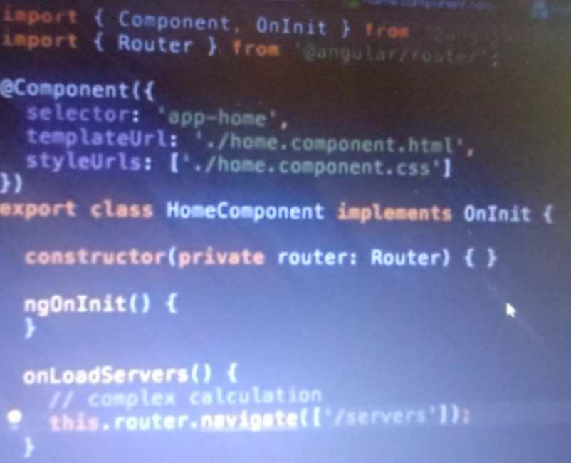

**How to pass id to route :**

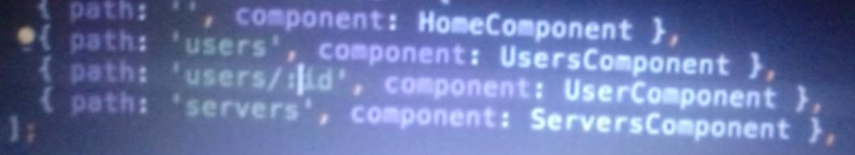

**How to fetch id or name in url into userComponent**

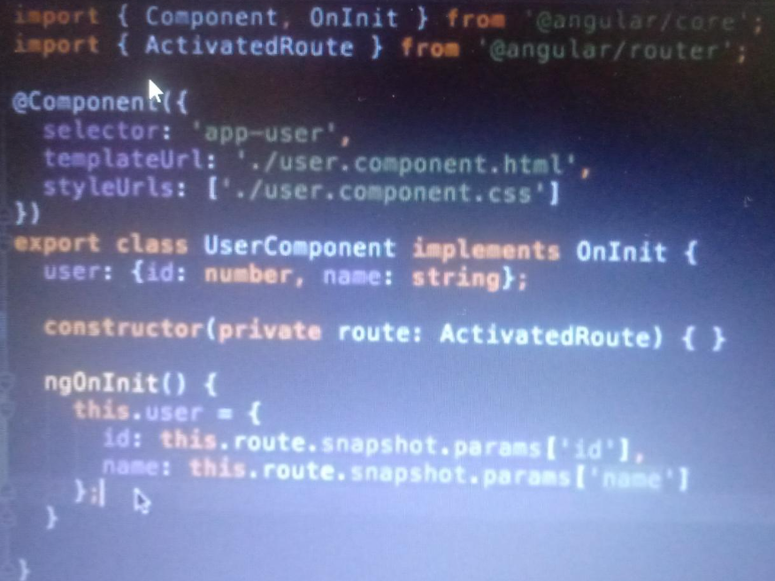

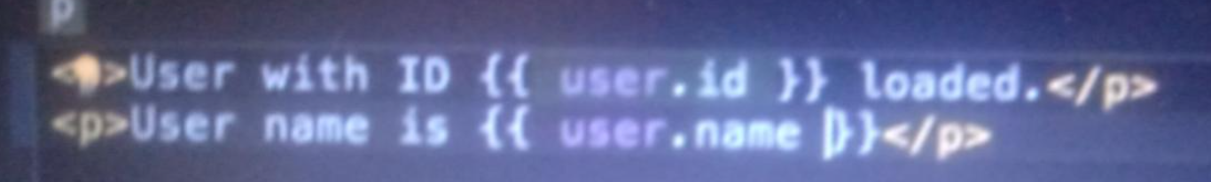

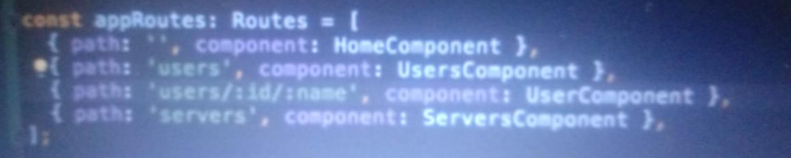

**On clicking anchar tag your route and data on page changed**

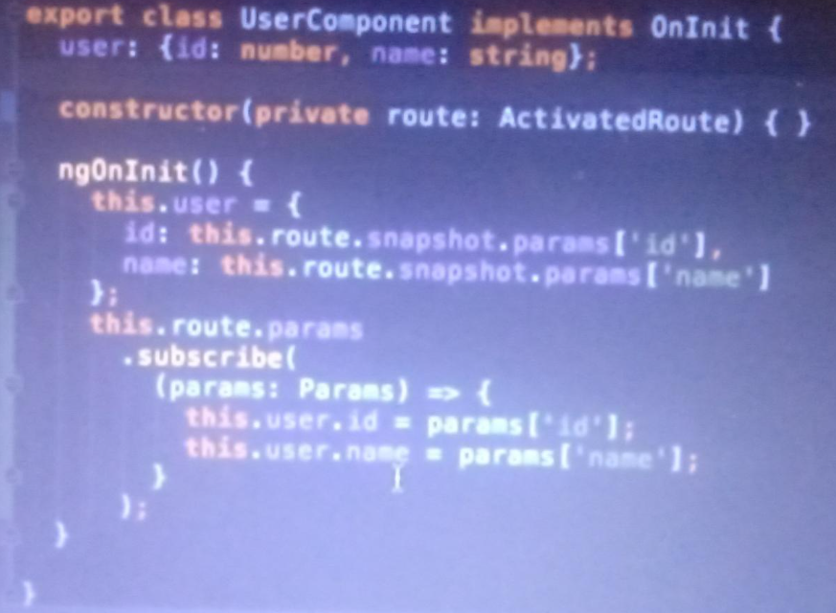

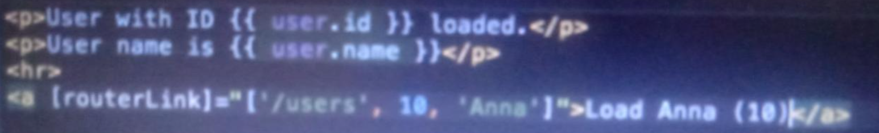

**Here you will have to subscribe because your data will not update on click anchor tag.**

**How to make your url as -** localhost:4200/users/1/edit?allowEdit=1#loading

Use all this inside tags as property binding

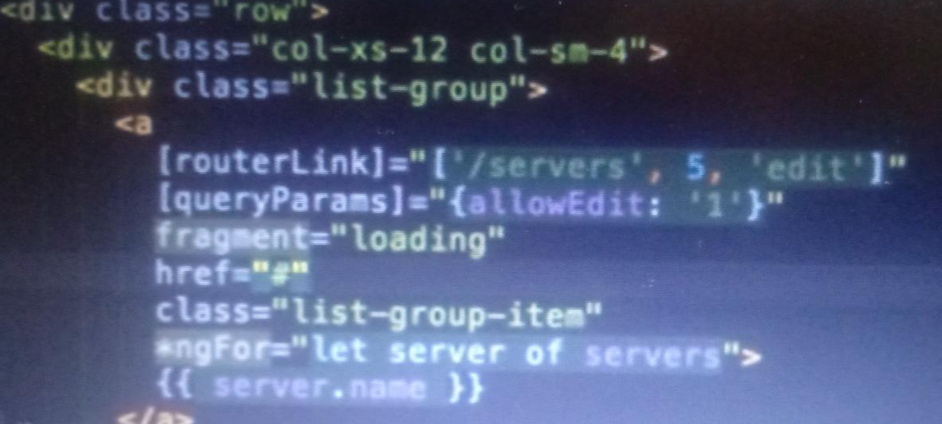

But if let’s say it’s on button click we have set url above one =>

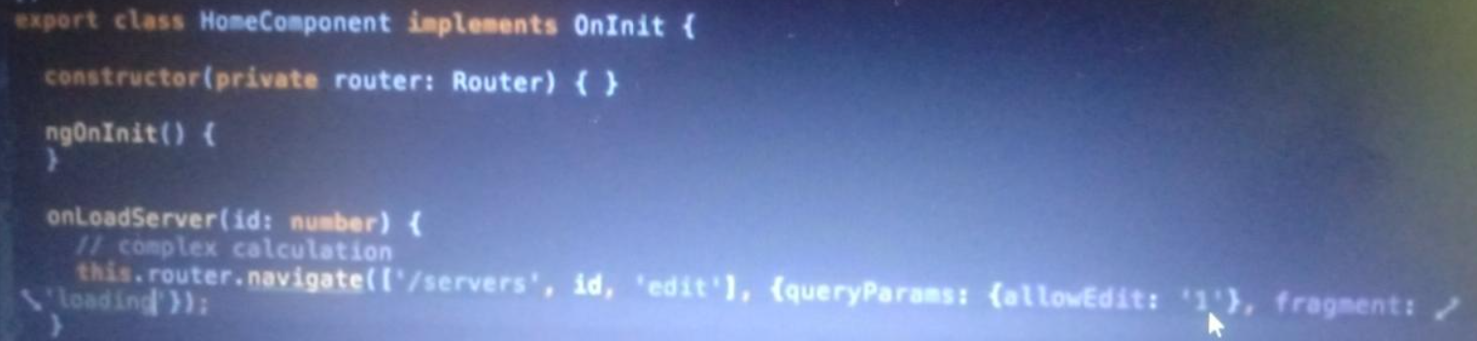

**How to get fragment and query parameter value**

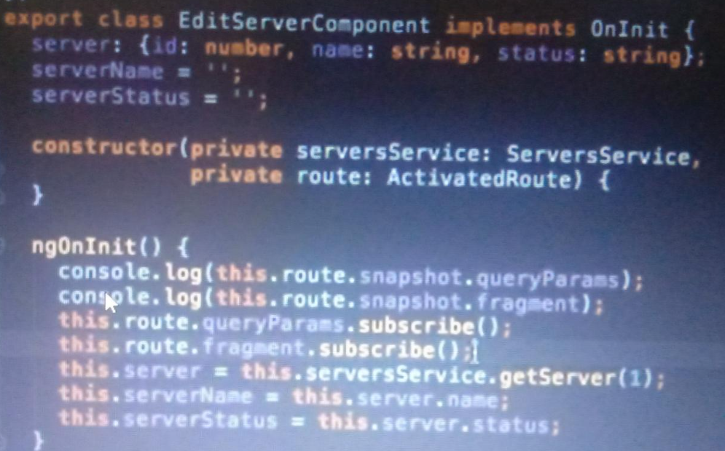

Your Url works like string but if want to use url as localhost:4200/users/1?

1 as number not string then use + sign before it

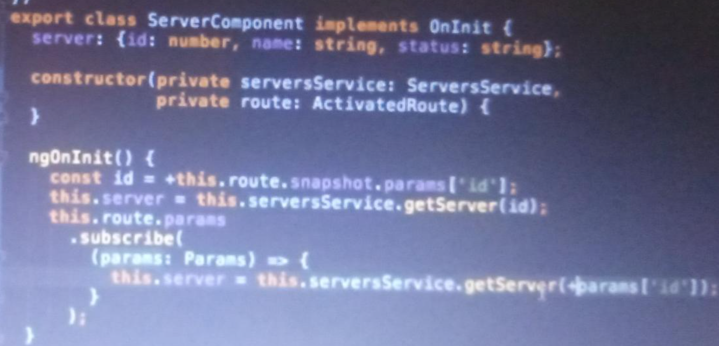

**How make child route for component :**

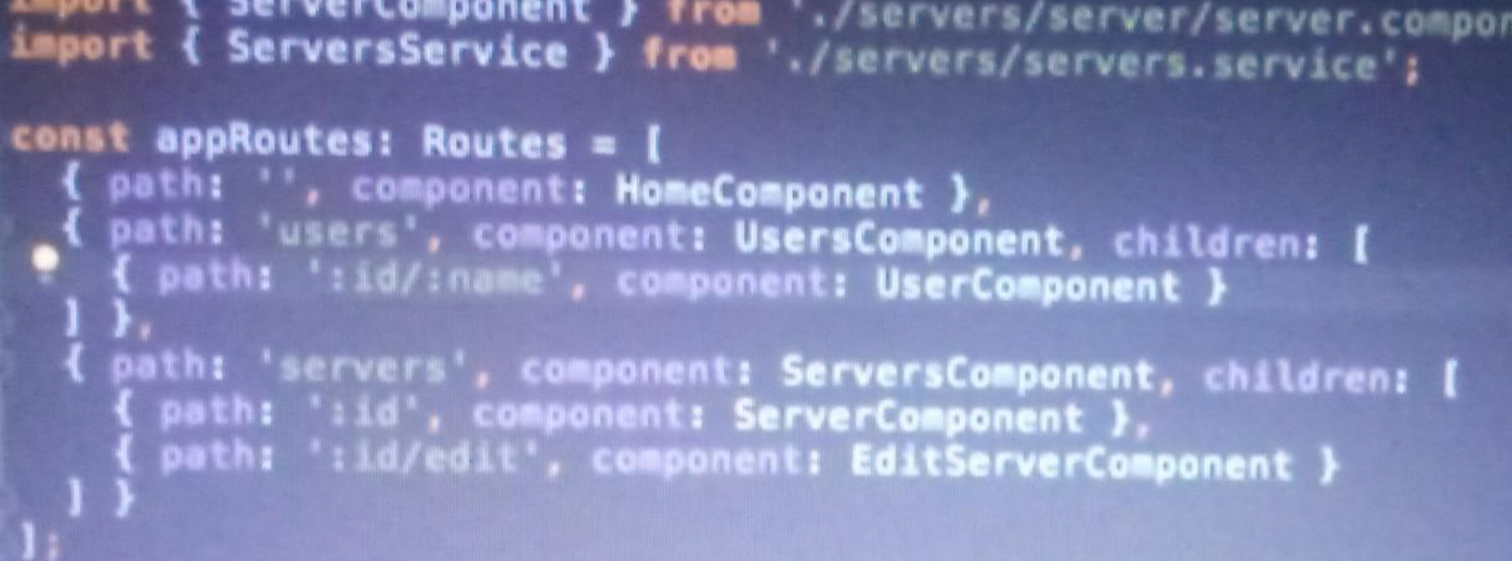

In userscomponent and serverscomponent we will put child outlet again

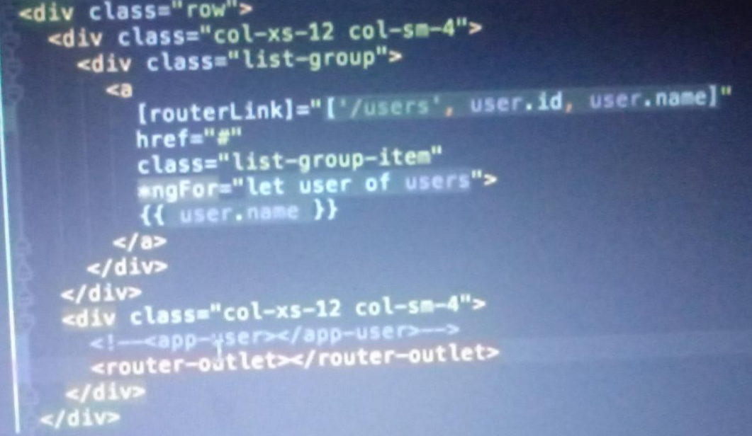

Instead of app user we will put router outlet

If you want change queryparamter value use query parmeter handlings in functions onces button click

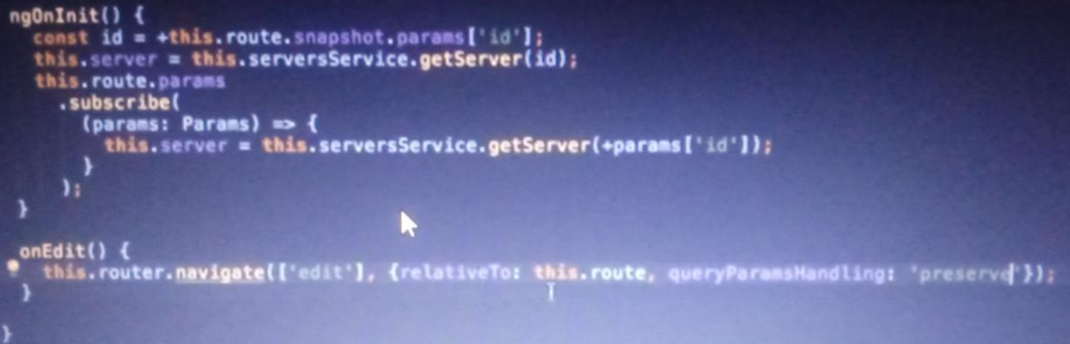

**How to make wild card route :**

**If anything url comes it will go to error page**

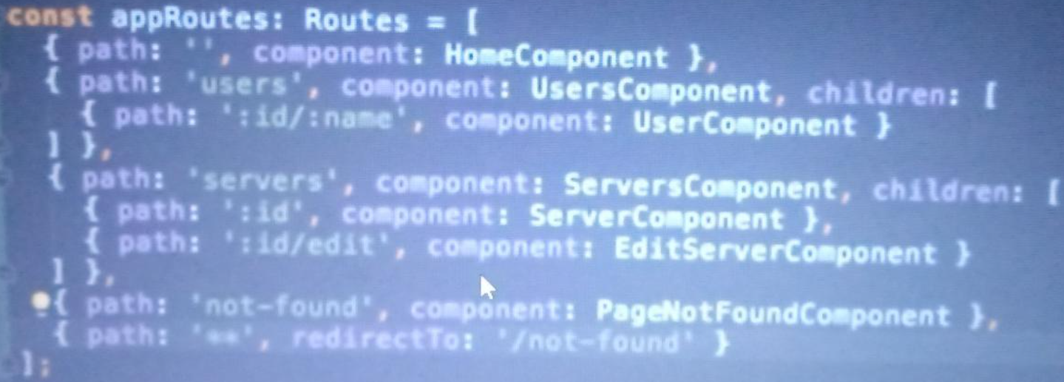

**If you want you create separate file for routing and add that in app module Ts:**

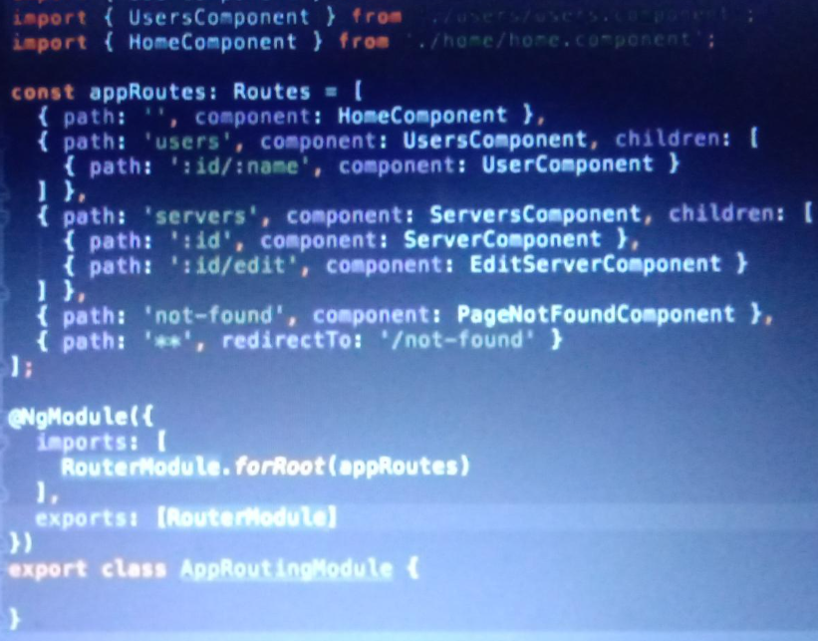

**Simply exports and import in app module ts - in imports of app.module ts**

**How to protect your link or routerlink - if user don’t have any access he will not able to get it information. => Need to use Gaurds with canActivate**

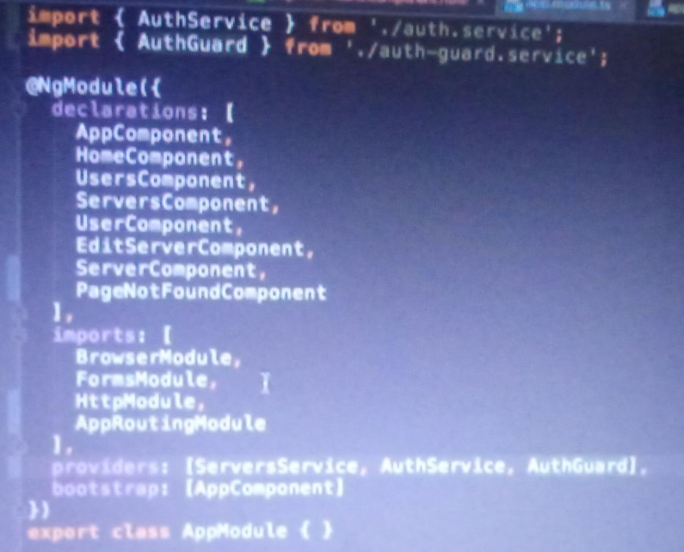

**Here you are importing to service which u created Auth service and guard.**

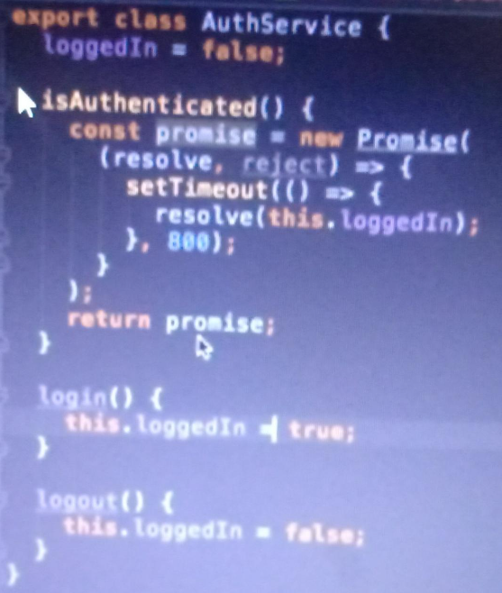

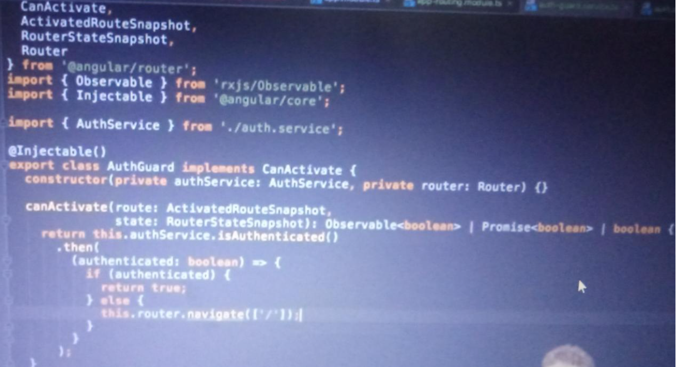

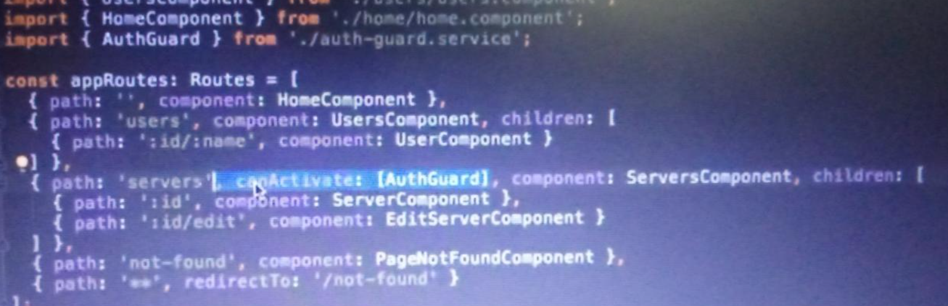

**Give this via canActive attribute in router.**

Server tab will not work unless user get login true. It will redirect to home directly after 800 ml.

**How to protect child routes:**

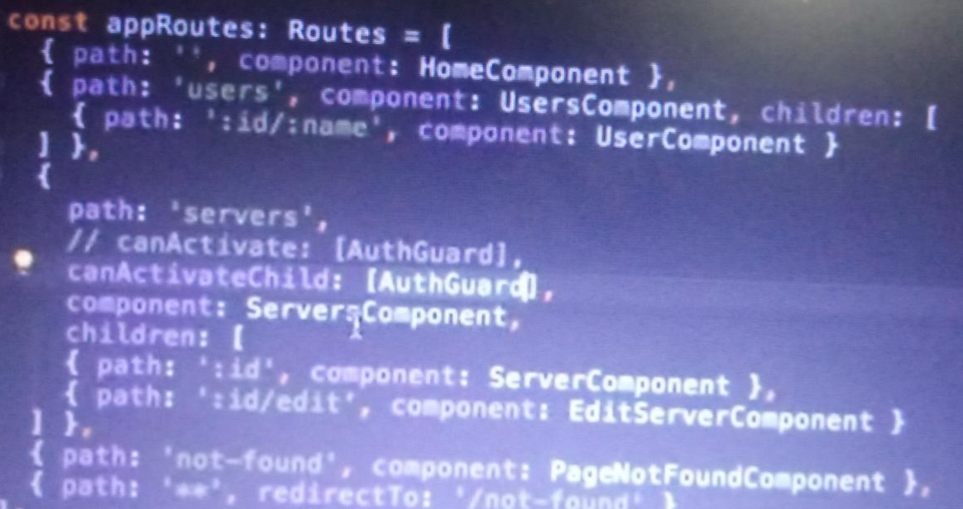

**canActiveChild is way to do**

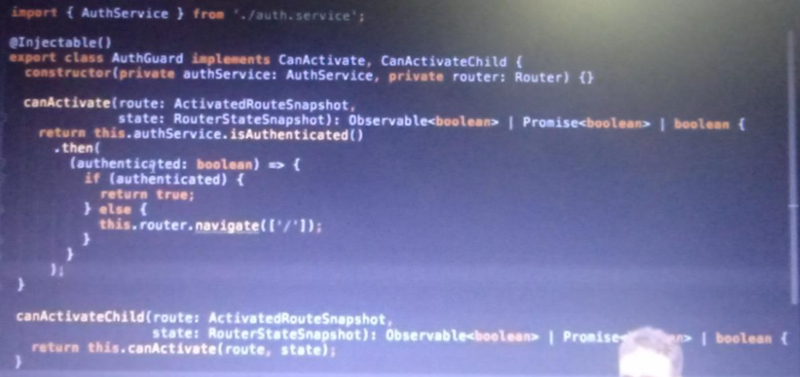

**How to pass static data from route :**

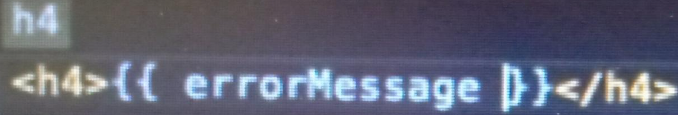

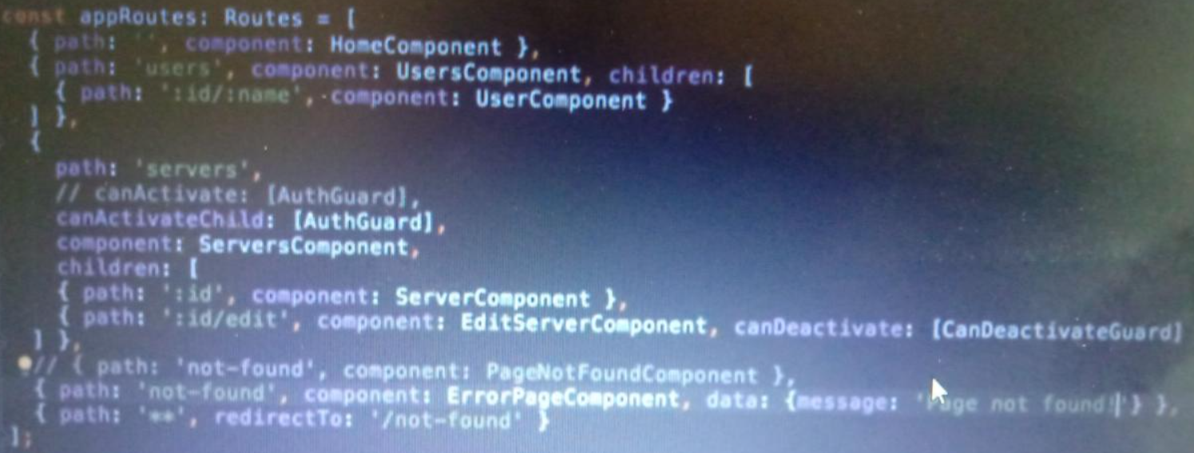

Here you will see error page component which has data we can use this in ts file of error page component.

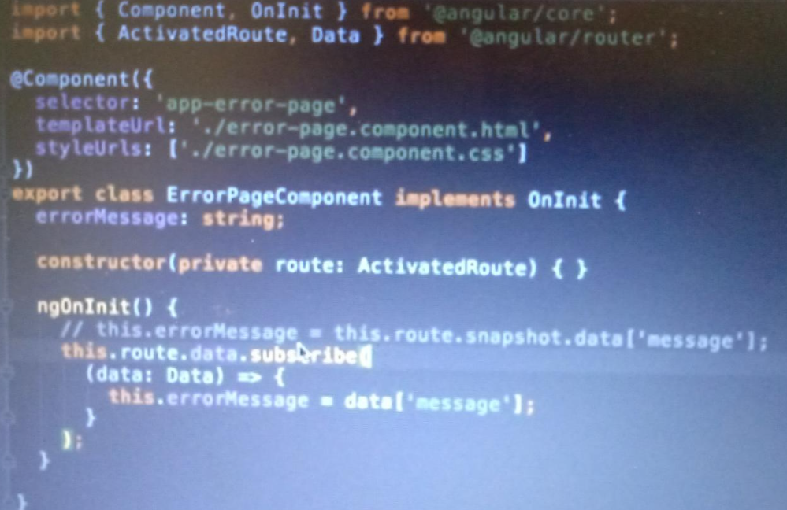

**How to use resolver when route is loaded?**

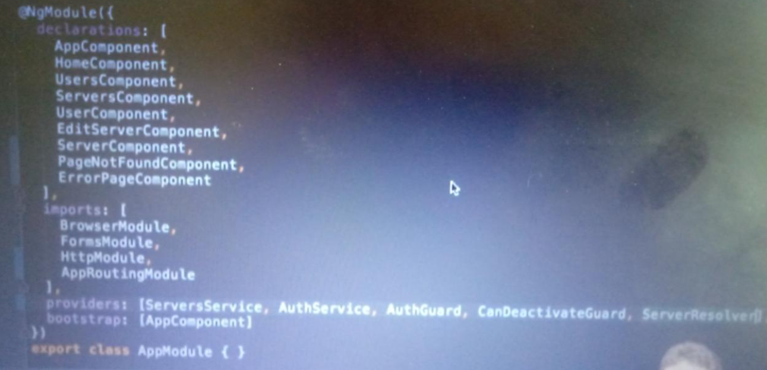

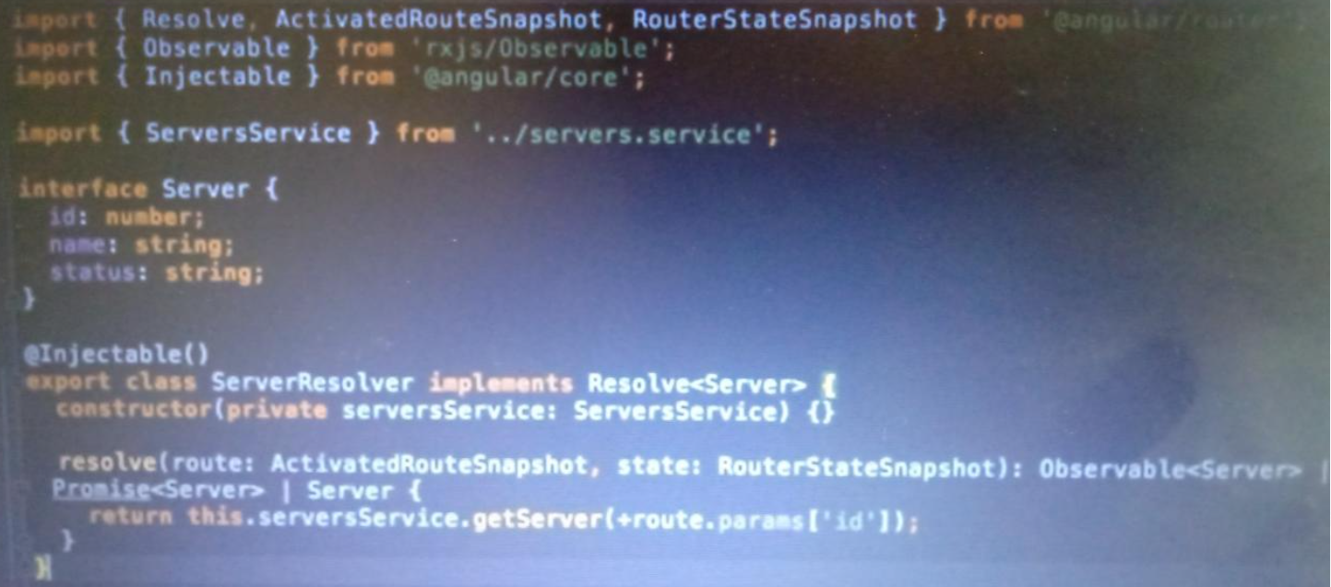

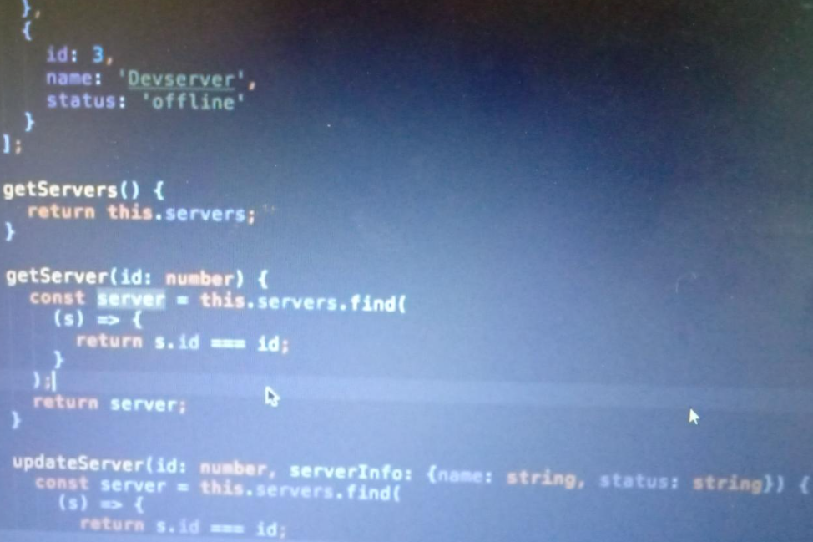

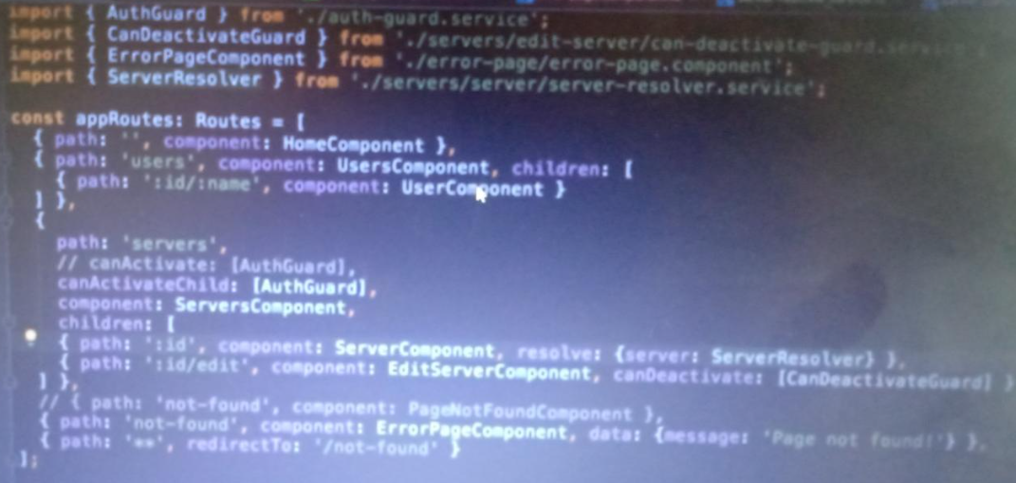

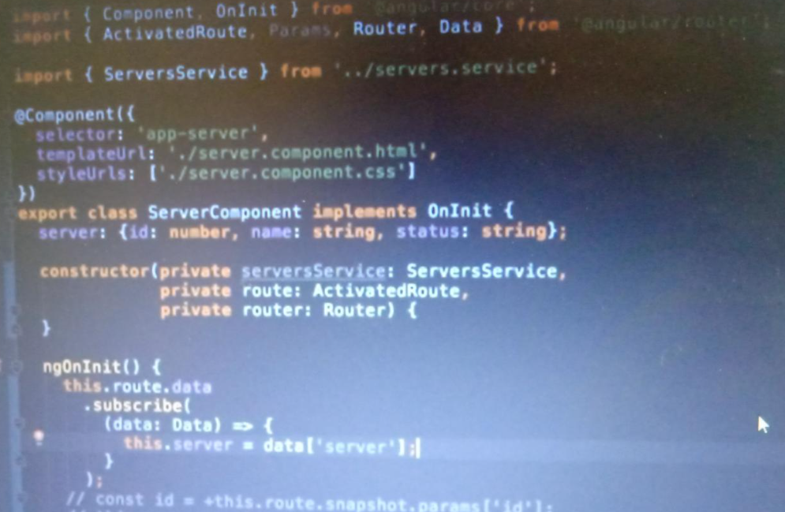

**In order to follow along smoothly with the course examples, make sure you install RxJS v6 by running**

* **npm install --save rxjs@6**

**In addition, also install the rxjs-compat package:**

* **npm install --save rxjs-compat**

**Observable means the stream of data process onces changes occurs and it will be done via subscribe model function.**

**If you don’t want to use emitter use subject in observable**

**import { Subject } from "rxjs";**

**import { Ingredient } from "../shared/ingredient.model";**

**export class ShoppingListService{**

**//ingredientChanged = new EventEmitter<Ingredient[]>();**

**ingredientChanged = new Subject<Ingredient[]>();**

**addIngredients(ingredient : Ingredient){**

**this.ingredients.push(ingredient);**

**this.ingredientChanged.next(this.ingredients.slice());**

**}**

**addSelectedItemInShoppingList(ingredient : Ingredient[]){**

**this.ingredients.push(...ingredient);**

**this.ingredientChanged.next(this.ingredients.slice());**

**}**

Here we use Subject instead of event emitter and instead of emit we put next

**How to use test driven template Forms?**

* First import form module in app module ts
* Make form and use ngModel on input box and for submitting form use onSubmit directive.
* If you want your data as object use ngForm as ref by any variable and use that in component for print.

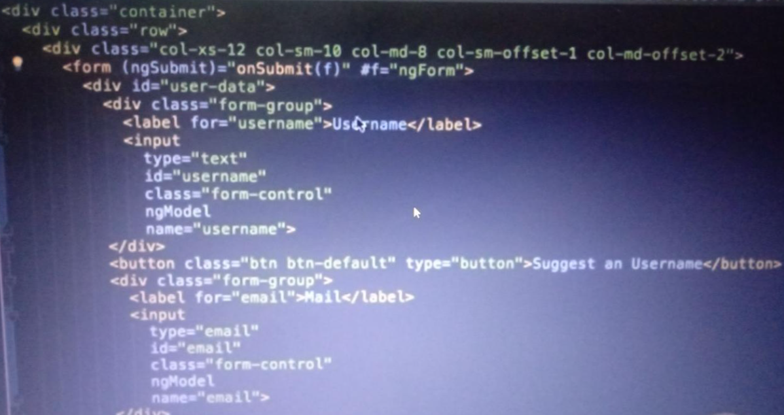

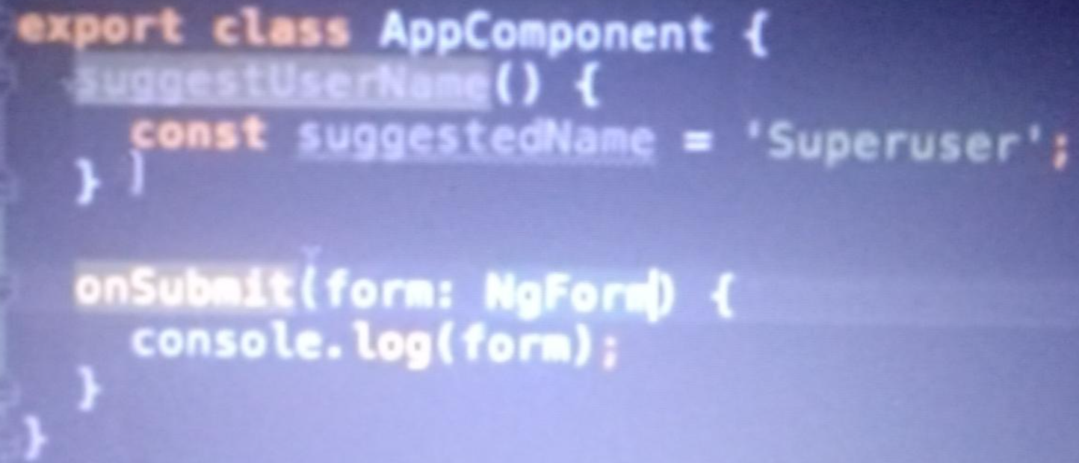

**If you don’t want to pass input in onSubmit you can use viewchild to retrieve ngForm data**

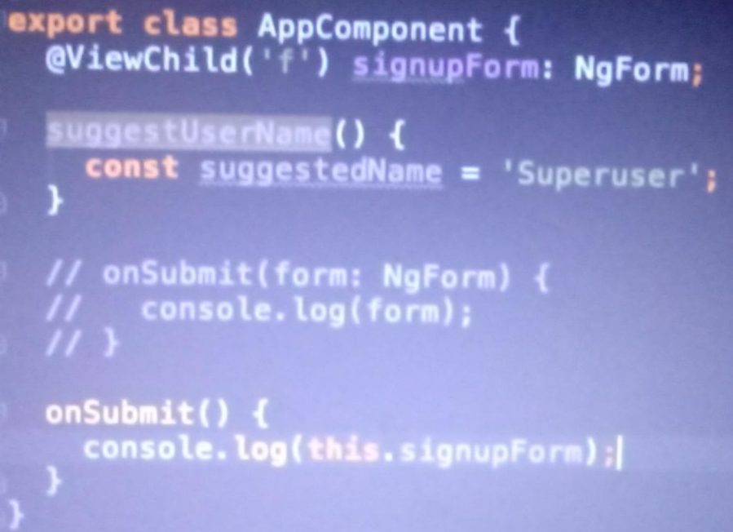

**If you want to disable button then take form ref with valid attribute and put in disable**

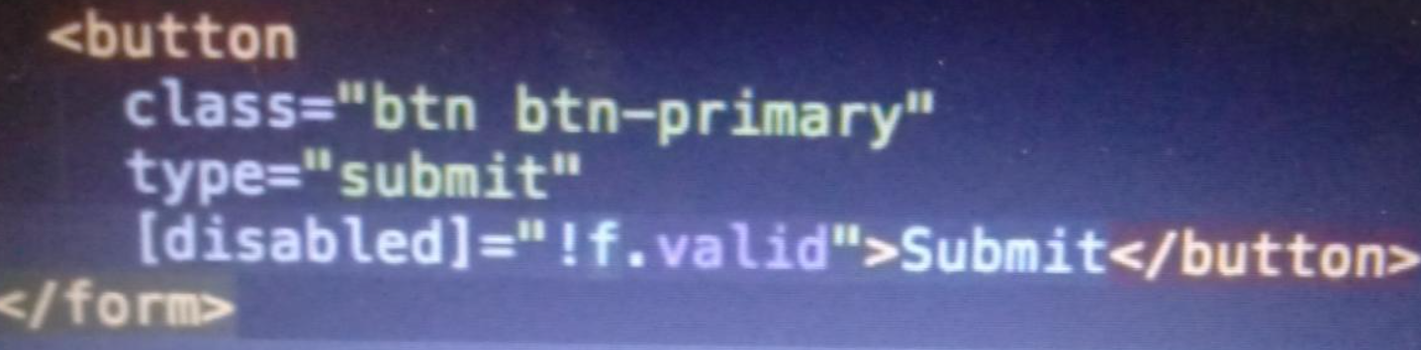

**If you want to put red border if invalid input put this in css file**

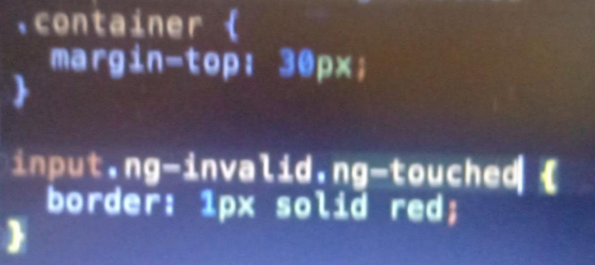

**If you want to show error page on untouched or invalid input put ref email with ngmodel and check condition**

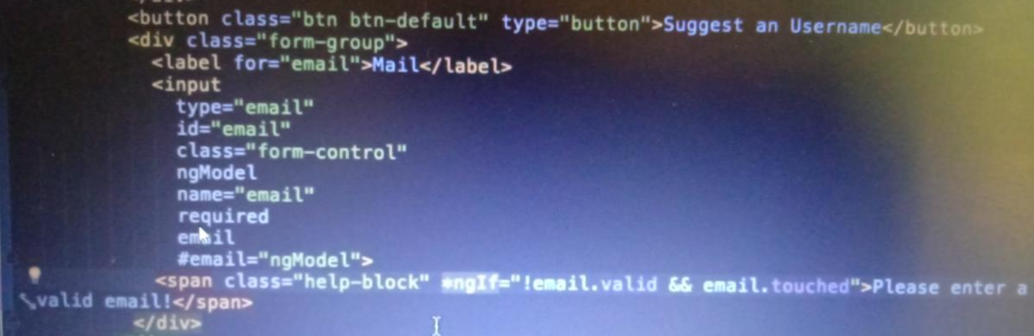

**Want to set default value in form ?**

**First make variable in ts file with any default value - defaultQue = ‘Pet’; pet is value of questions.**

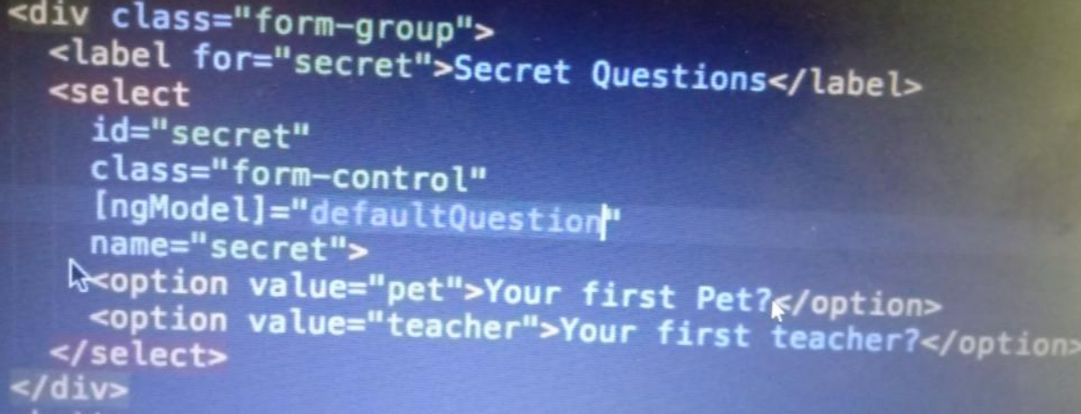

**If u wan to use ngmodel as two binding use below make answer empty variable in TS file**

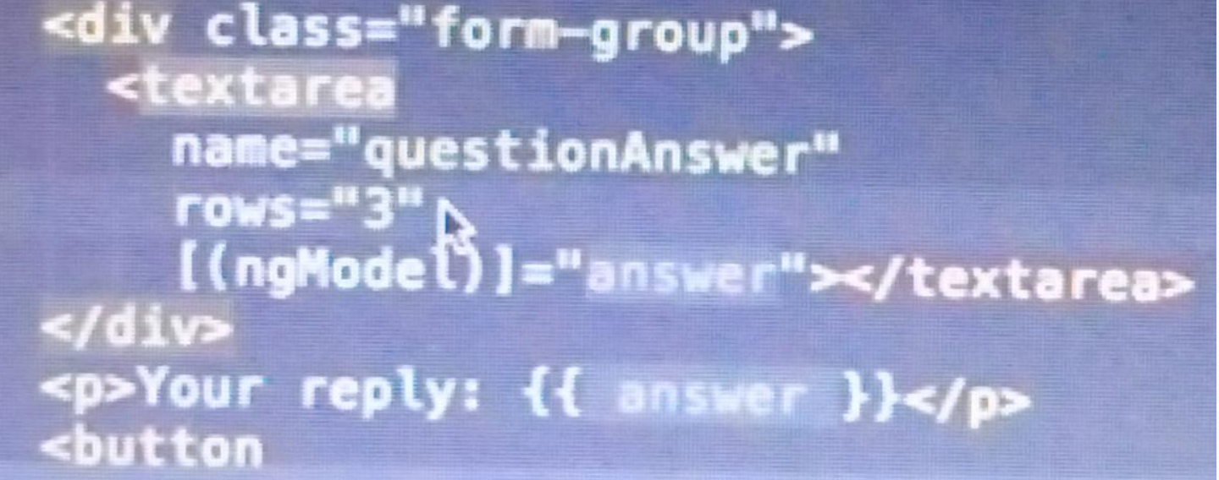

**If we want separate and make groups for each field then used ngmodelgroups also validated user data**

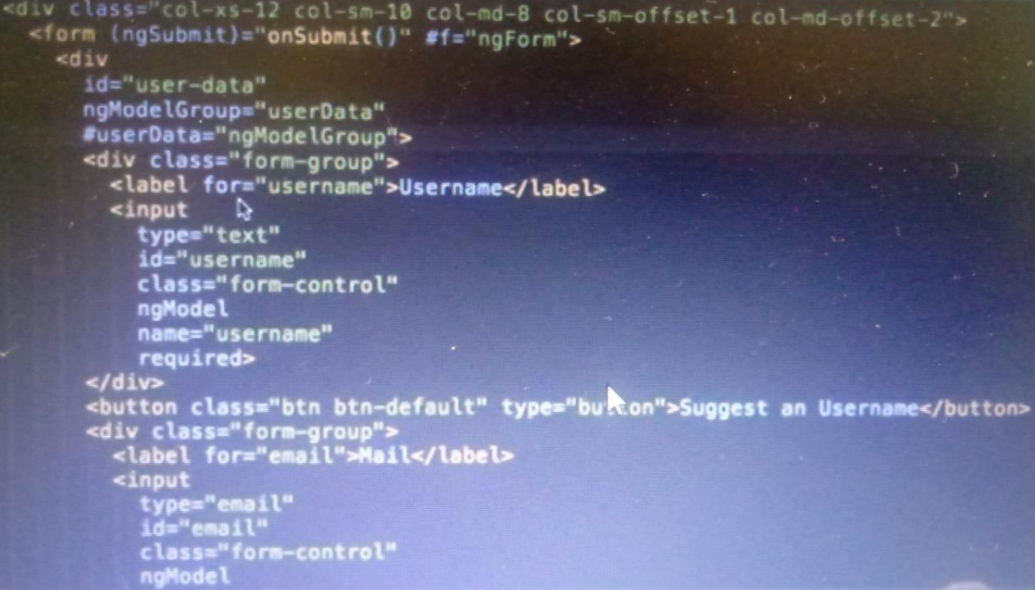

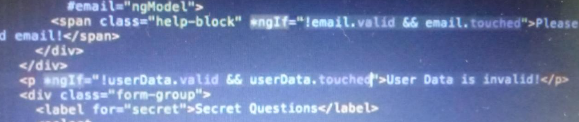

**Handle radio button :**

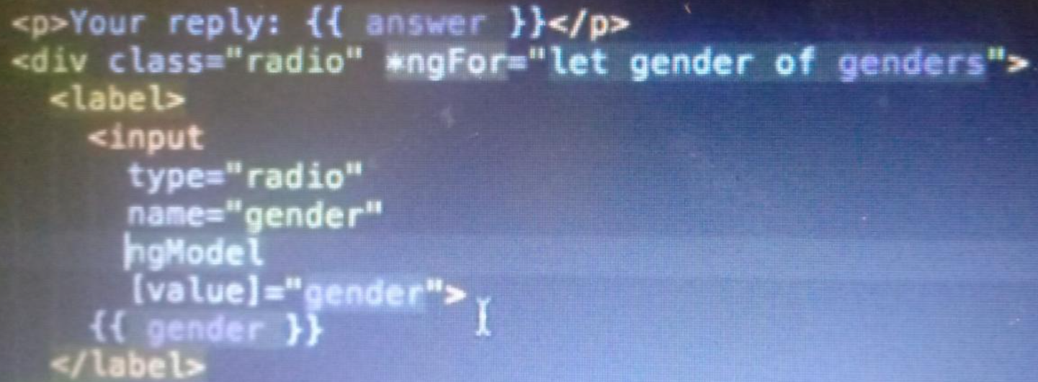

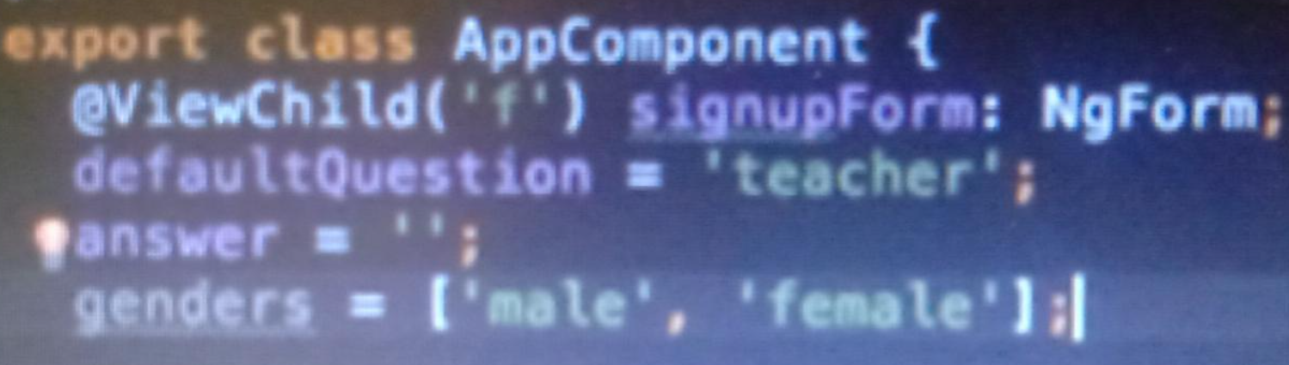

**What is Set value and patch value in form?**

**Set value will override your existing value by set value**

**Patch value will no override**

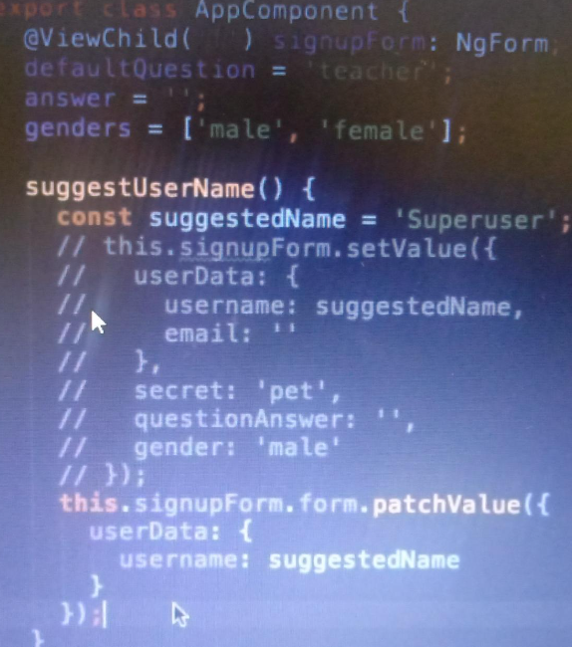

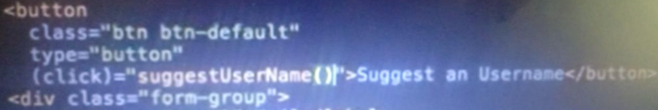

**Extract form data :**

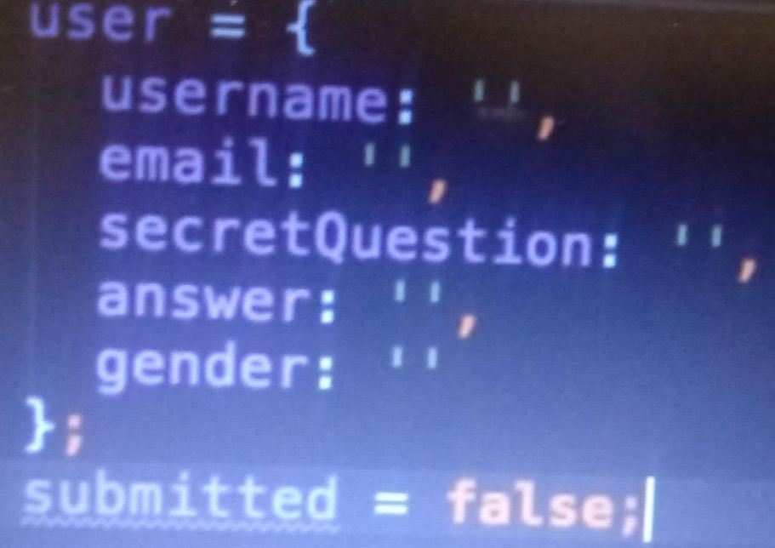

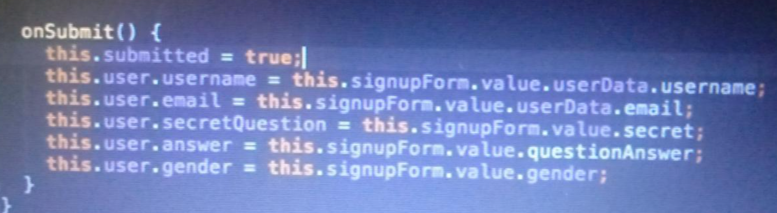

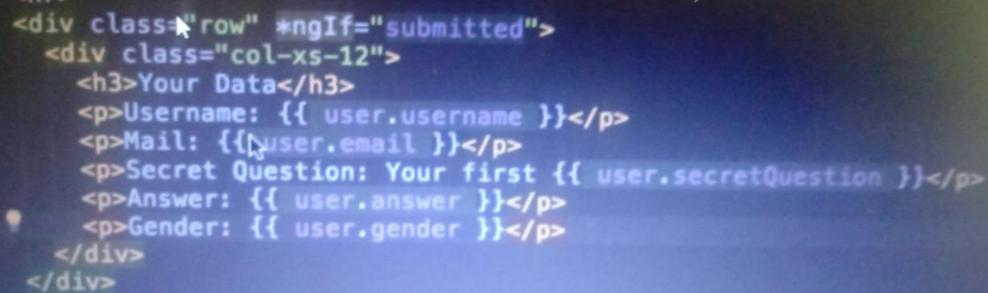

**How to reset form ?**

**Use reset function in onsubmit on form**

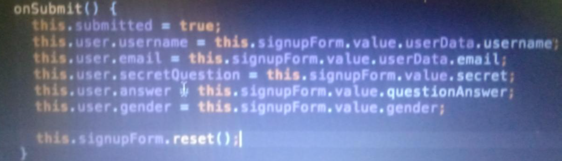

**How to use reactive form?**

**Reactive setup :**

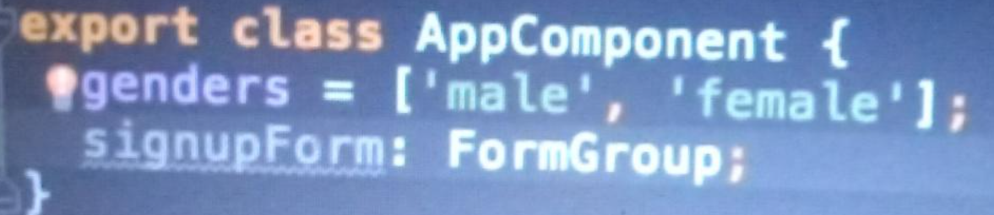

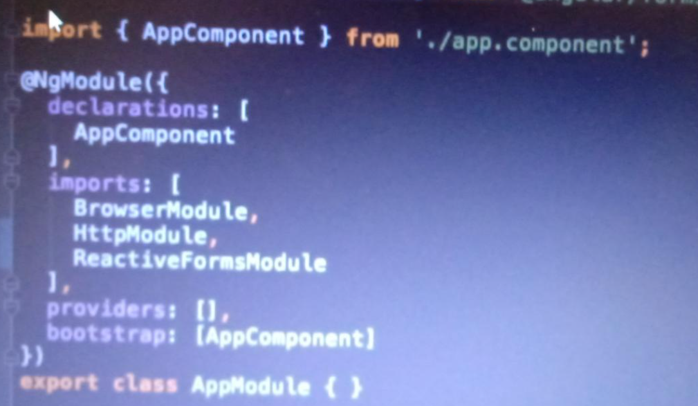

**Sync reactive html and TS data with form**

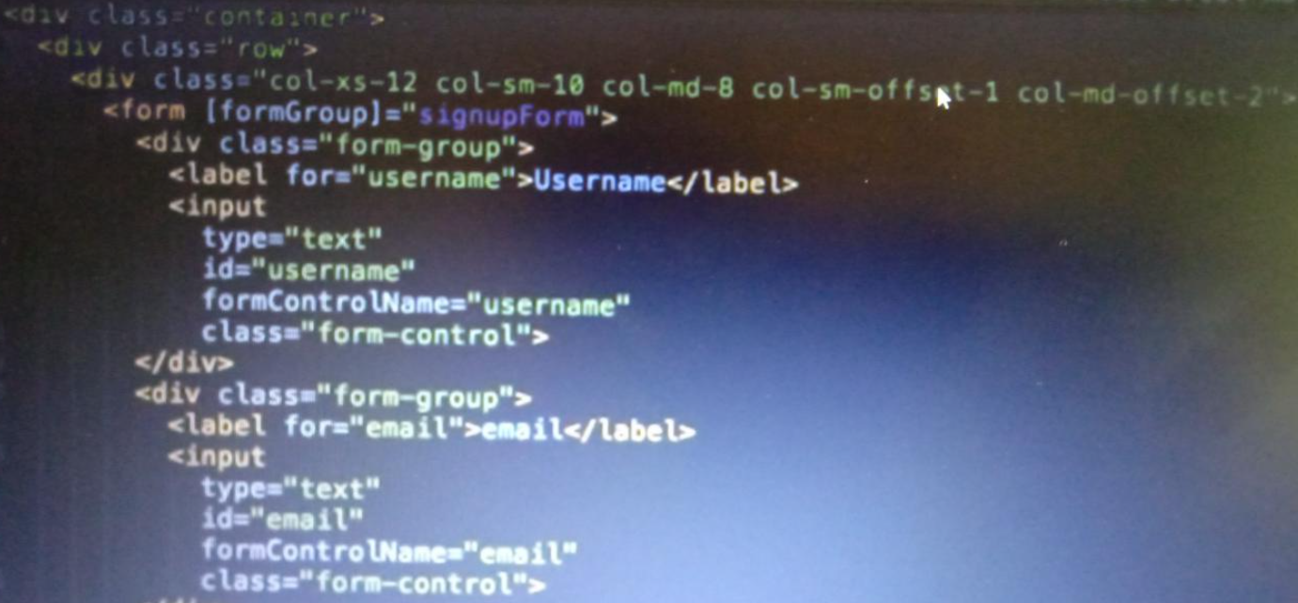

**You will have to write signupForm with formGroup and put formControlName**

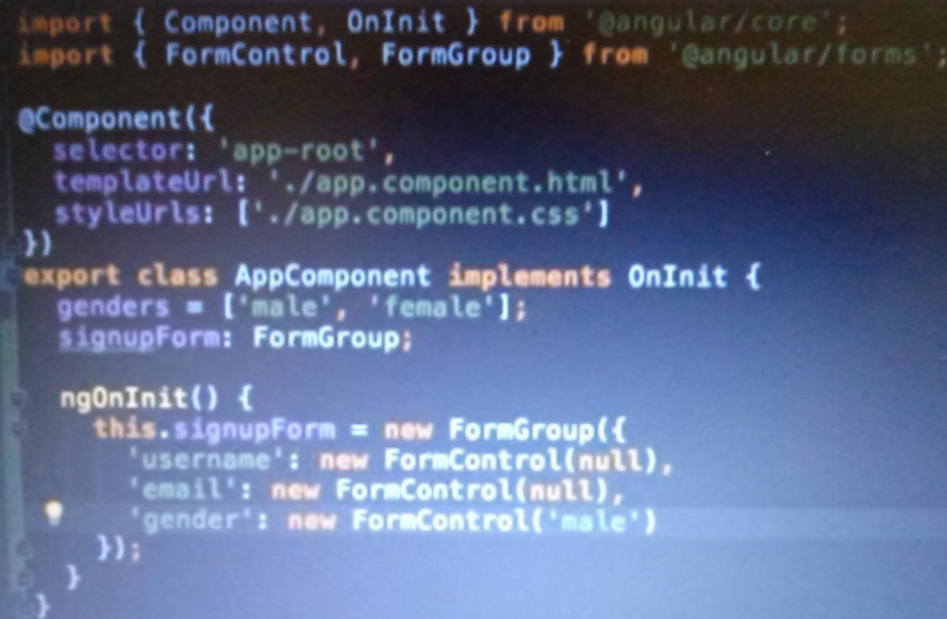

**How to put on submit to form ?**

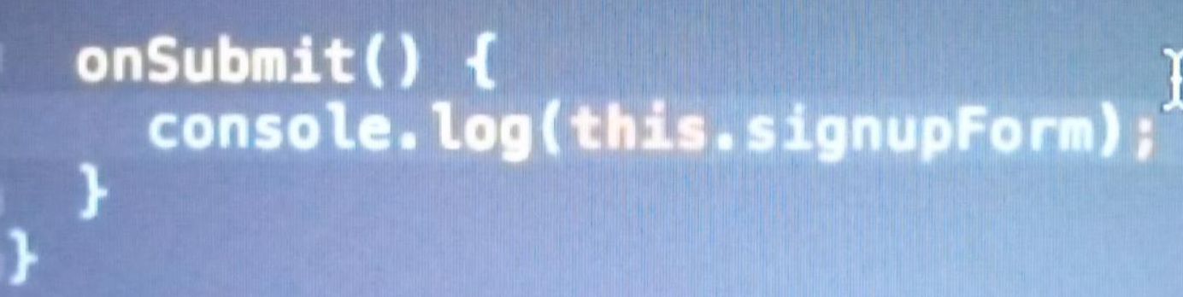

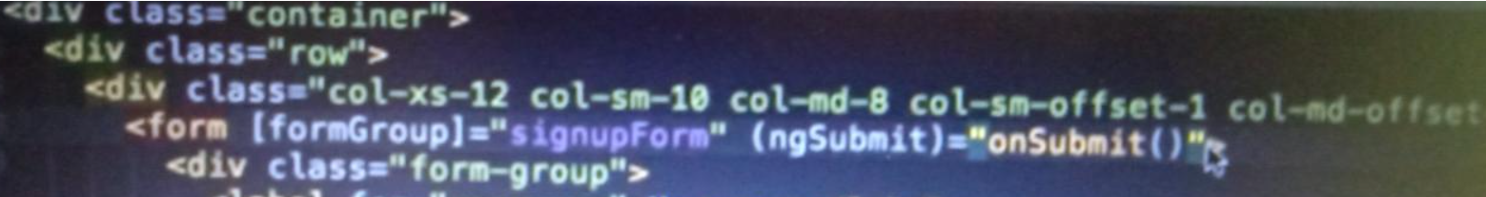

**How to validate in reactive form?**

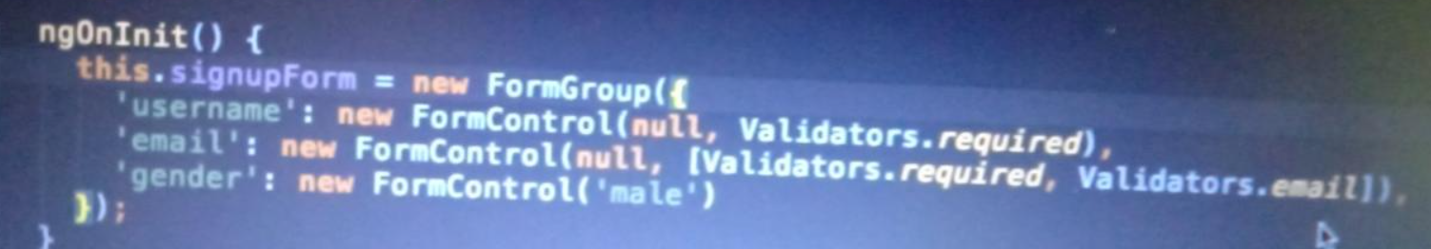

**How to validate n print ?**

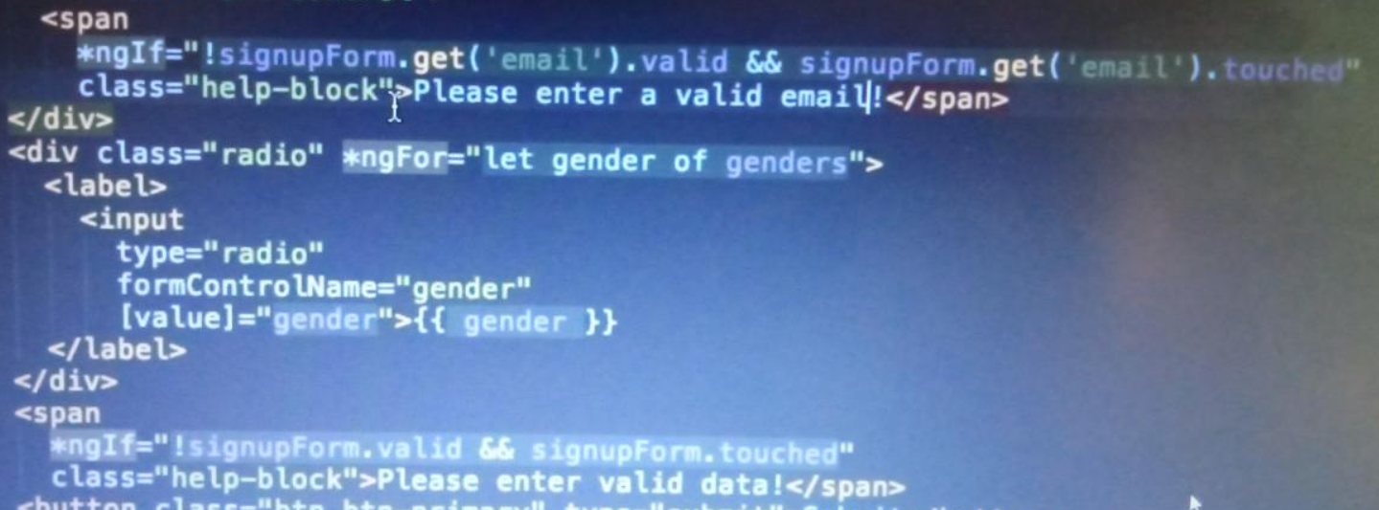

**How to use nested field group?**

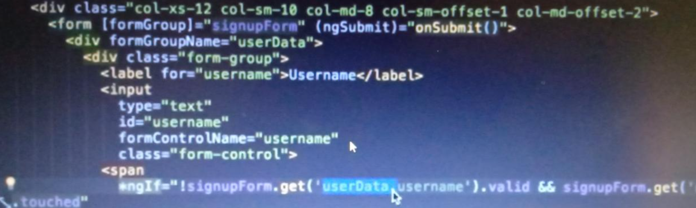

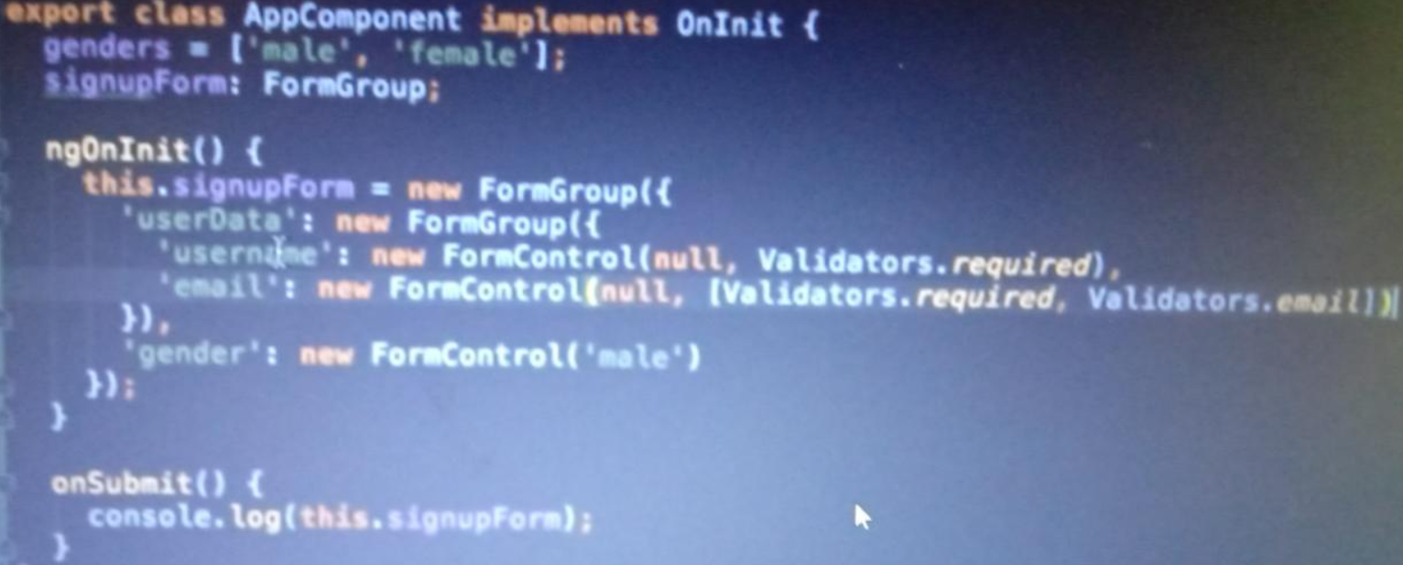

**On clicking button input box come and we will get data as in array format.**

**make and put down one by one input box only click to button**

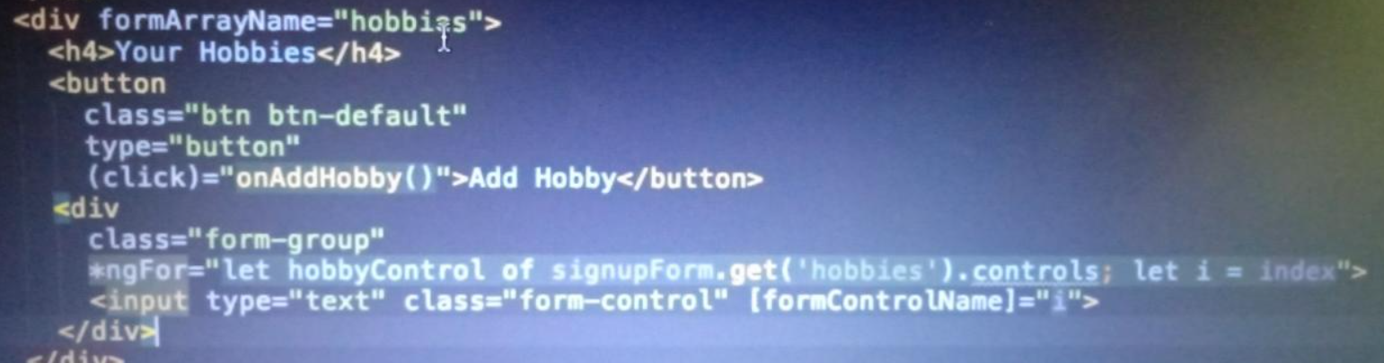

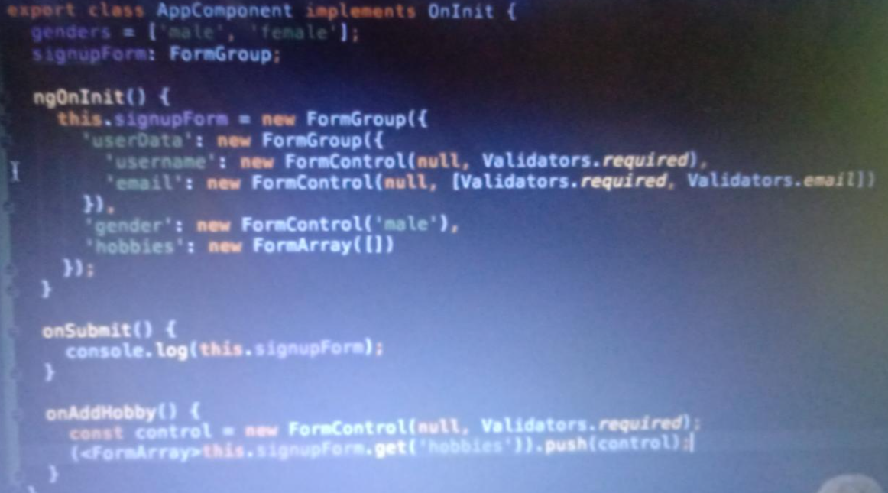

**How to put multiple validate in reactive form?**

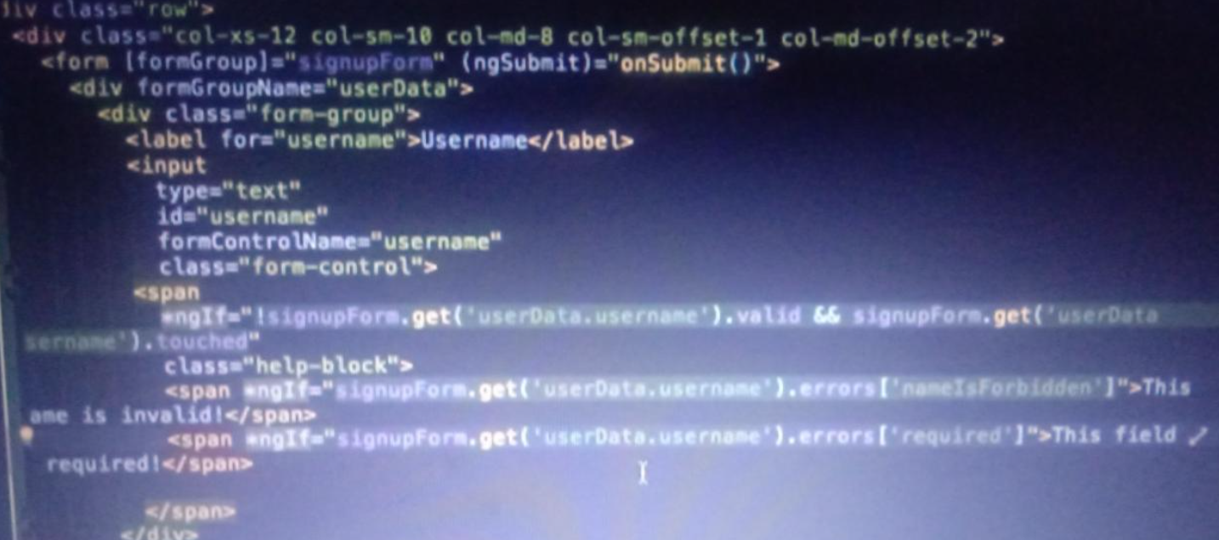

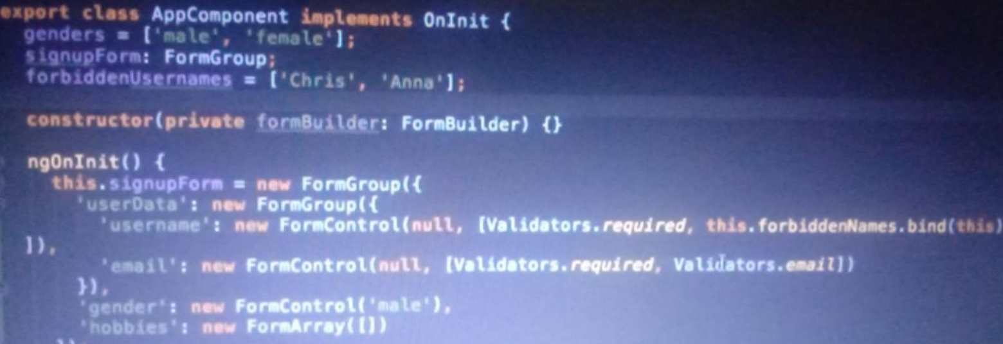

**forbidden username is array which users not allowed to be write in input box then you will get two error one is empty field and second is invalid user**

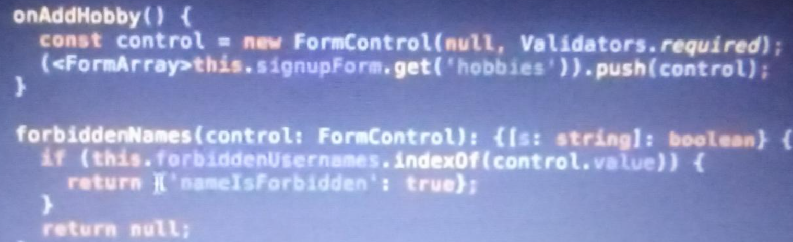

**If you want to validate in async way use promises?**

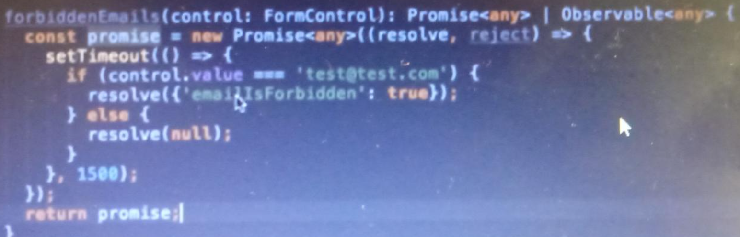

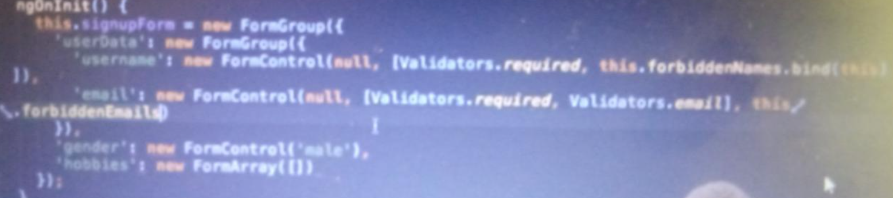

**How to value change and status change in form? Put this in ngOnInit()**

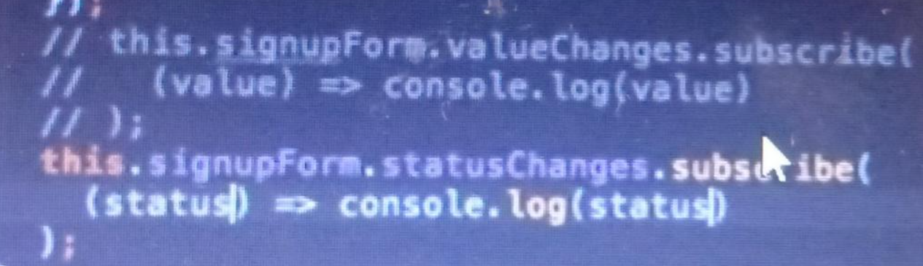

**How to set , patch and reset in form ?**

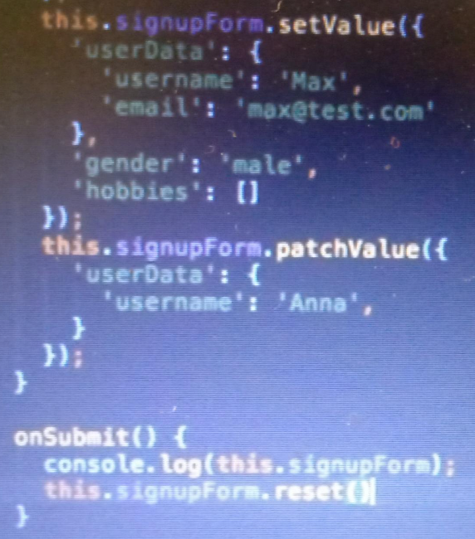

**How to pass array object to one component to other component :**

**1 ) todo component**

**<div *ngFor="let todo of todos">**

**<app-todo-item [todo]="todo"></app-todo-item>**

**</div>**

**2 ) todo-item component**

**<div class="container-fluid">**

**<div class="my-3">**

**<h3>{{todo.sno}} | {{todo.title}}</h3>**

**<p>{{todo.desc}}</p>**

**<button class="btn btn-danger">Delete</button>**

**</div>**

**</div>**

**In - ts file**

**import { Component, OnInit , Input} from '@angular/core';**

**import {Todo} from 'src/app/Todo'**

**export class TodoItemComponent implements OnInit {**

**@Input() todo : Todo;**

**How to give event on click button:**

**<div class="container-fluid">**

**<div class="my-3">**

**<h3>{{todo.sno}} | {{todo.title}}</h3>**

**<p>{{todo.desc}}</p>**

**<button class="btn btn-danger" (click)="onClickMethod()">Delete</button>**

**</div>**

**</div>**

**export class TodoItemComponent implements OnInit {**

**@Input() todo : Todo;**

**constructor() { }**

**ngOnInit(): void {**

**}**

**onClickMethod(){**

**console.log("click done...")**

**}**

**}**

**How to pass values from children to parent component via method onclick**

**Todo item html:**

**<div class="container-fluid">**

**<div class="my-3">**

**<h3>{{todo.sno}} | {{todo.title}}</h3>**

**<p>{{todo.desc}}</p>**

**<button class="btn btn-danger" (click)="onClickMethod(todo)">Delete</button>**

**</div>**

**</div>**

**Todo item ts:**

**import { Component, OnInit , Input,Output,EventEmitter} from '@angular/core';**

**export class TodoItemComponent implements OnInit {**

**@Input() todo : Todo;**

**@Output() todoDelete : EventEmitter<Todo> = new EventEmitter();**

**constructor() { }**

**ngOnInit(): void {**

**}**

**onClickMethod(todo:Todo){**

**this.todoDelete.emit(todo);**

**console.log("click done...")**

**}**

**}**

**Here you can see as output we are passing value to event emitter to Todo component via onclickmethod. That will catch by Todo components.**

**Todo html:**

**<div *ngFor="let todo of todos">**

**<app-todo-item [todo]="todo" (todoDelete)="deleteTodo(todo)"></app-todo-item>**

**<!--<app-todo-item [todo]="todo" (todoDelete)="deleteTodo($event)"></app-todo-item>-->**

**</div>**

**Todo ts:**

**...**

**ngOnInit(): void {**

**}**

**deleteTodo(todo:Todo){**

**const index = this.todos.indexOf(todo);**

**this.todos.splice(index, 1)[0];**

**console.log(todo)**

**}**

**}**

**How to use ngSubmit and ngModel in angular**

**add-todo html**

**<form (ngSubmit)="onSubmitForm()" class="row ">**

**<div class="mb-3">**

**<label for="add title" class="form-label">Add Title</label>**

**<input type="text" class="form-control" name="title" id="title" [(ngModel)]="title" placeholder="add title here..">**

**</div>**

**<div class="mb-3">**

**<label for="add desc" class="form-label">Add Description</label>**

**<textarea class="form-control" id="desc" name="desc" rows="2" [(ngModel)]="desc" placeholder="add description here.."></textarea>**

**</div>**

**<div class="d-grid gap-2 d-md-block">**

**<button type="submit" class="btn btn-primary ">Add TODO</button>**

**</div>**

**</form>**

**add-todo ts:**

**import { Component, OnInit , Output,EventEmitter} from '@angular/core';**

**export class AddTodoComponent implements OnInit {**

**title:string;**

**desc:string;**

**@Output() todoAdd : EventEmitter<Todo> = new EventEmitter();**

**constructor() { }**

**ngOnInit(): void {**

**}**

**onSubmitForm(){**

**const todo = {**

**sno:9,**

**title:this.title,**

**desc :this.desc,**

**active:true**

**}**

**this.todoAdd.emit(todo);**

**}**

**}**

**Output will emit into TODO components**

**<div class="row">**

**<div class="col-md-6 offset-md-3">**

**<div class="alert alert-primary text-center" role="alert">**

**<h3>Todo App using Angular Framework !! </h3>**

**</div>**

**<div class="card">**

**<div class="card-body">**

**<div class="offset-md">**

**<app-add-todo (todoAdd)="addTodo($event)"></app-add-todo>**

**</div>**

**</div>**

**</div>**

**</div>**

**</div>**

**todo ts:**

**.......**

**addTodo(todo:Todo){**

**this.todos.push(todo);**

**console.log(todo)**

**}**

**}**

**Use ngif and else block**

**<div class="row my-2">**

**<div class="col-md-6 offset-md-3">**

**<div class="alert alert-primary text-center" role="alert">**

**<h3>Todo App using Angular Framework !! </h3>**

**</div>**

**<div class="card">**

**<div class="card-body">**

**<div class="offset-md">**

**<app-add-todo (todoAdd)="addTodo($event)"></app-add-todo>**

**</div>**

**</div>**

**</div>**

**<div *ngIf="this.todos.length===0; else elseBlock">**

**<div class="alert alert-danger my-2" role="alert">**

**<strong>No Todos to display</strong>**

**</div>**

**</div>**

**</div>**

**<ng-template #elseBlock>**

**<div *ngFor="let todo of todos">**

**<app-todo-item [todo]="todo" (todoDelete)="deleteTodo($event)"></app-todo-item>**

**<!--<app-todo-item [todo]="todo" (todoDelete)="deleteTodo(todo)"></app-todo-item>-->**

**</div>**

**</ng-template>**

**</div>**

**LocalStorage in angualr js**

**export class TodosComponent implements OnInit {**

**todos:Todo[];**

**localItem:string | null;**

**constructor() {**

**this.localItem = localStorage.getItem("todos");**

**if(this.localItem == null){**

**this.todos = []**

**}**

**else{**

**this.todos = JSON.parse(this.localItem);**

**}**

**}**

**ngOnInit(): void {**

**}**

**deleteTodo(todo:Todo){**

**const index = this.todos.indexOf(todo);**

**this.todos.splice(index, 1);**

**localStorage.setItem("todos",JSON.stringify(this.todos));**

**console.log(todo)**

**}**

**addTodo(todo:Todo){**

**this.todos.push(todo);**

**localStorage.setItem("todos",JSON.stringify(this.todos));**

**console.log(todo)**

**}**

**Routing in angular:**

**Add app-routing.module file in app.module.ts**

**import { NgModule } from '@angular/core';**

**import { BrowserModule } from '@angular/platform-browser';**

**import { FormsModule } from '@angular/forms';**

**import { AppComponent } from './app.component';**

**import { TodosComponent } from './Components/todos/todos.component';**

**import { TodoItemComponent } from './Components/todo-item/todo-item.component';**

**import { AddTodoComponent } from './Components/add-todo/add-todo.component';**

**import { RouterModule } from '@angular/router';**

**import { RouterTestingModule } from "@angular/router/testing";**

**import { AboutComponent } from './Components/about/about.component';**

**import { AppRoutingModule } from './app-routing.module'**

**@NgModule({**

**declarations: [**

**AppComponent,**

**TodosComponent,**

**TodoItemComponent,**

**AddTodoComponent,**

**AboutComponent**

**],**

**imports: [**

**BrowserModule,**

**FormsModule,**

**RouterModule,**

**RouterTestingModule,**

**AppRoutingModule**

**],**

**providers: [],**

**bootstrap: [AppComponent]**

**})**

**export class AppModule { }**

**Make app.routing-module.ts file**

**import { Routes,RouterModule } from '@angular/router';**

**import { NgModule } from '@angular/core';**

**import { TodosComponent } from './Components/todos/todos.component';**

**import { AboutComponent } from './Components/about/about.component';**

**const routes: Routes = [**

**{**

**path:'',**

**component:TodosComponent,**

**},**

**{**

**path:'about',**

**component:AboutComponent,**

**},**

**];**

**@NgModule({**

**imports:[RouterModule.forRoot(routes)],**

**exports:[RouterModule]**

**})**

**export class AppRoutingModule {};**

**Write router outlet and router link in app.componet html file**

**<nav class="navbar navbar-dark bg-dark navbar-expand-lg">**

**<div class="container-fluid">**

**<a class="navbar-brand" routerLink="/">Navbar</a>**

**<button class="navbar-toggler" type="button" data-bs-toggle="collapse" data-bs-target="#navbarNav" aria-controls="navbarNav" aria-expanded="false" aria-label="Toggle navigation">**

**<span class="navbar-toggler-icon"></span>**

**</button>**

**<div class="collapse navbar-collapse" id="navbarNav">**

**<ul class="navbar-nav">**

**<li class="nav-item">**

**<a class="nav-link active" aria-current="page" routerLink="/">Home</a>**

**</li>**

**<li class="nav-item">**

**<a class="nav-link" routerLink="about">About</a>**

**</li>**

**</ul>**

**</div>**

**</div>**

**</nav>**

**<router-outlet></router-outlet>**

**Parent to Child data pass:**

**Parent - about,todo and Child - header**

**Header ts**

**export class HeaderComponent implements OnInit {**

**@Input() header : string;**

**constructor() { }**

**ngOnInit(): void {**

**}**

**}**

**<div class="alert alert-primary text-center" role="alert">**

**<h3>{{header}}</h3>**

**</div>**

**about html**

**<div class="row my-2">**

**<div class="col-md-6 offset-md-3">**

**<app-header [header]="header"></app-header>**

**export class AboutComponent implements OnInit {**

**header : string;**

**constructor() {**

**this.header = "Todo App About using Angular Framework !!";**

**}**

**ngOnInit(): void {**

**}**

**}**

**todo html**

**<div class="row my-2">**

**<div class="col-md-6 offset-md-3">**

**<app-header [header]="header"></app-header>**

**export class TodosComponent implements OnInit {**

**todos:Todo[];**

**header:string;**

**localItem:string | null;**

**constructor() {**

**this.header = "Todo App using Angular Framework1 !!";**

**Use selector in different way**

**Todo html**

**<div class="row my-2">**

**<div class="col-md-6 offset-md-3">**

**<app-header [header]="header"></app-header>**

**<!--<app-filters></app-filters>-->**

**<!--<div app-filters></div>-->**

**Filter ts**

**@Component({**

**// selector: 'app-filters',**

**//selector: '[app-filters]',**

**templateUrl: './filters.component.html',**

**styleUrls: ['./filters.component.css']**

**})**